**Conversation Guide: Digital Health Modernization Discovery Research - Caregiver Group**

**Bold text identify the moderator’s questions.**

*Text in italics are Jen’s observations and interpretations of the participant.*

[Text in brackets are interpretations in participants’ direct quote.]

**Background (5 minutes)**

To get started, I’d like to get a little background information about you, and your experience with the VA.

1. **Can you tell me a little bit about yourself?**

I am my husbands full time caregiver.

I recently moved to Florida from Arizona.

I’m not going to say it was extremely hard to transfer over service, but it was a challenge because I have never done that before.

**What do you mean transferring service:**

Transferring over to the VA. So he can go to the VA in Florida instead of Arizona.

Big challenges are we are not near a VA hospital. We are like, it took me 2-3 hours to get to St. Pete.

But they do have clinics here, it’s not what we are used to as far as the all services that they have.

**What brought you to Florida from Arizona:**

Just a change. But we didn’t really look into, well we were told there were lots of VA’s down there. Well yeah, I guess I should have been more specific and said VA hospitals. It is a big difference between what they do offer between a clinic and a hospital.

**Free time:**

My free time? My free time is reading a book. Or taking a nice hot bath. When my husband is sleeping.

I get up extra extra early to get my me time. I up about 5am to take my me time for a couple hours. Then I start breakfast and medications, and making sure I have all appointments are set.

But I have to take care of me first in the morning.

**That sounds like a long day:**

Yes.

**And what is your husband’s name:**

My husband’s name is Yancy.

1. **When did you step into this full-time caregiver role?**

It was about 2014.

**When did he get out of the military:**

Officially 2008.

**Which branch:**

USMC, Marine Corps.

**Tell me a little bit about moving into caregiver role what was promising that and what the process was like:**

It was like a huge challenge at first. Well I don’t think for me, I didn’t envision that. But as a wife and someone that loves their spouse you move into. You move into whatever is going to mold and fits your spouse’s needs.

1. **Do you personally receive any benefits from the VA?**

No. What do you mean by benefits? Like am I in the military? No.

**Part of the caregiver program**:

Yes.

**Can you tell me a little bit about that program:**

Well, the whole thing is changing now so it’s kind of hard for me to tell you what it is going forward. But I can tell you about being in there.

The greatest experience was getting in Arizona, in our corps, and we were getting to know the nurses, social workers, and things like that.

They made it a smooth transition as possible. I never had a bad experience with them. They checked in a lot.

Moving to Florida is a little bit different. It is bigger here I guess. The state is bigger. I haven’t had negative anything.

But we are moving into a new way, as they say. It’s all new now. I don’t have much information as of yet.

3**.a. What VA benefits does [Veteran] receive?**

Disability, he’s rated at 100 T&P, total and permanent.

He gets his meds.

We do a lot of tele-health, especially now with COVID.

**Did you do it prior as well**:

A little bit but now it is more so all the tele-health now.

**Primary care or other health care received through the VA**:

Yes. Psych. GI.

We haven’t had a chance; he was in physical therapy, like aqua therapy in Arizona but they don’t have any of that here.

And now since it is the pandemic I don’t think he would even attempt to a pool to go around other people. But they don’t offer it here.

1. **Does [Veteran] have any family members they claim as dependents?**

Just me, that’s it.

1. **Do you manage any of [Veteran's] VA benefits online?**

I do.

**5.a. Where do you do that?**

My HealtheVet.

**Other sites:**

If there was a document I needed, I would go to Ebenefits.

**Anything else you do on ebenefits:**

No, that is the only thing I do on there.

The basic thing I am on is My HealtheVet to order medications, to talk to his doctors. Because if you call, I knot they are busy and it is a lot, and anyways it is best to have a paper trail of things.

We were on it and needed a device. They provided the iPad for tele-health.

It is not like usually advertised, but I heard of it from a fellow caregiver and the doctor was on it. I would say within a week or two it was delivered here.

**iPad you are referring to:**

Yeah, to use tele-health and things like that.

**Do you remember how did you requested that:**

I requested it through the primary care. And then all of a sudden the social worker called and asked me just questions - what did he did need it for.

At first he asked if we could afford it but I said lets go back to the beginning sir. Because I find that quite, kind of disrespectful to ask. If I could I would. *Participant is talking about they would buy an iPad themselves if they could afford it.* He kind of calmed down. Then it was delivered.

I don’t know if that’s one of their question they are supposed to ask. But it had my hair standing up a bit. I was like it is already humbling to ask for things. I don’t ask anything for free, this is for my husband benefit.

He [social worker] said you can’t do games or anything. I guess they had problems in the past and I understand that.

So it is strictly for tele-health and things like that.

**Primary care provider is where you requested it**:

Yes.

1. **Do you use any mobile apps to manage [Veteran's] health?**

No, I don’t know of any.

The only mobile app I use is the Calm app, to do mediation, but its not through the VA.

We do a lot of guided meditation, its not an app but it is a service a that this lady does. She started out with doing it through Walter Reed and that is 4-5 times a week and it is just wonderful. He needs that and I need that too.

**For iPad that was delivered by the VA, do you know of any apps or programs you use to access telehealth appointments:**

No, I don’t. I just got it so I am working through it now.

**Mental model of health at the VA (20 minutes)**

Now I’d like to hear about your experience first learning about VA benefits. **(10 minutes)**

1. **How did you learn about the health care available to [Veteran] through the VA, and what was the process of applying for and accessing those benefits?**

Through the vet center, Wounded Warrior Project, fellow veterans, fellow veteran spouses.

**Process for applying:**

Yes. The process, we had a representative, kinda through the VA, but it was an entity of the VA. We went to down to their main center and they had representatives there.

**And that representative was helping you with applications:**

Yes.

**What was the process like as in how it was completed paper/online:**

It was like on paper but then some of it was online.

**Time from applying to rating and healthcare:**

It wasn’t that long. Perhaps maybe 6 months.

**When did you apply, prior to leaving the Marine Corps:**

This was after but I wish they had something they have now. You know while they are in. Because there were issues while he was in that were not addressed.

It was harder. Because when you get out you don’t know what to do.

Now it is a lot easier now because you have these like, wounded warrior department, and things like that to guide you through.

**I know you mentioned it was harder once he was. Does anything come to mind about the challenges there:**

Really just articulating what it issues is.

My husband is a Marine, always will be a Marine. With his training and what he was taught it was never talk about things. Like issues like you know PTSD. You just keep moving. You keep going. So it was harder with his training and to come out to have these issues it was really hard for him to articulate it to someone. Hey these are the issues that I am dealing with.

**So overcoming that hurdle of identifying these things and talking about them:**

Yes and shame.

**I am sure that is a really powerful emotion to get over:**

Yes.

1. **Do you use any private medical providers outside the VA for any of [Veteran] health care needs?**

Yes. Podiatry, gastroenterology.

It was before we got to Florida, it was physical therapy, like the aqua therapy, but it isn’t offered here.

**Are they covered by the VA or outside health insurance:**

No, it is covered by the VA because we are so far way from places like the VA. You know over 30 miles.

**What about your healthcare. Do you have private insurance:**

It is through the caregiver program.

**Through the VA:**

Yes.

1. **Manage it online**:

Yes, especially with this pandemic.

**Do you have separate accounts for you an your husband:**

Through My HealtheVet, no., I don’t think we get a My HealtheVet. *Participant is referring to caregivers not having an account through the caregiver program?*

**Where do you go to manage it:**

Through the doctor and online through their services and on their websites.

**Are these doctors at the same hospital or in town providers: Yeah, in town providers.**

**Do those doctors have a website like My HealtheVet:**

Yeah, kind of but not as intricate as that.

**Anything sticks out the My HealtheVet has but those other websites don’t:**

The meds.

You can see all of the healthcare notes and things like that.

**Managing yours outside of the VA and managing your husbands through My HealtheVet and the VA, how is the experience navigating between the two:**

I am more so amped on my end to be able to talk to my doctors faster. Because I don’t think that they have the magnitude of patients as the VA.

But on the other end of that, for my husband’s health I am able to talk to the primary care, even if it’s not in real time, I’ll send a message, ok they’re getting right back to you.

*Seems like participant is saying even though it’s slower communication she likes being able to send a message.*

**Response rate seems faster on your end:**

During the pandemic I can’t say, it’s different. But before that yes. Now it is kind of like the same.

But with the VA the primary care got right back to him by email through My HealtheVet.

**What changed since the pandemic that changed the faster response through My HealtheVet:**

I think there are not many people going in so they have time to respond to you.

1. **How would you explain a “disability rating” to a new Veteran or their caregiver?**

I would just describe it as just make sure you are seen if you have an issue.

One veteran’s disability will not ensure the another veteran’s disability. It is individualized. So it would be hard for me to say my husband is 100 percent, your husband can get, because I am not a healthcare professional and I don’t know the extent of what they are going through.

My best advice would be get seen.

And if I am talking to the caregiver and if their spouse is unable to articulate what is actually really going be their mouthpiece. Make notes.

I took a lot of notes, I didn’t know a lot about like PTSD and mental health. Just joking things down, this happened and this happened. Because I didn’t understand it and he didn’t understand it. So I just wrote it down so when we went into the doctor, I said he said this he did this. *Participant is saying she recounted veterans behavior to doctor from notes*. And you know the nightmares, and I just documented it. I don’t know why I was doing it. But I didn’t understand what was going on so my best thing was to I write it down so we could discuss it with the healthcare provider.

**What does the rating allow you to do:**

Well, I guess if you are 100 percent you are able to, all of your, if you have other problems they will take care of that.

But I am confused with that too because there are other issues like with my husband. I was told not to put them in, don’t put in any other ratings, because you won’t get any more money.

It’s not what I am looking for, money. There is really no amount of money that can compensate for what problems are.

But you want them documented. You want them addressed because I shall say with the caregiver, she’ll ask if he has IBS, yes, it’s all in the notes but he’s not rated for it. She said well he’s not rated for it. I said I was told once he got 100 percent to not put in any of the things so that is where the confusion is for me.

I was advised not to do that, he’s at 100 percent we’ll take care of everything. But when he has these issues like IBS and it is notated in the doctors note, oh well but it’s not rated. Well I was advised to not get it rated. So that is the confusing thing.

**Are you saying the VA provider are saying that they can’t provide care because it wasn’t rated:**

No, they do. But if you have a visit with the caregiver coordinator and they say what do for your husband or what are his ailments. Oh well his IBS is acting up, well I [care coordinator] don’t see it in the rating. Well, your not going to see it in his rating because I didn’t put it in there because he is already 100 percent.

1. **In your mind, is there a relationship between "disability" and "health care"?**

Yes, I would say so.

It would impact it because they always look at the notes and always say they don’t see he is rated it for it.

But that doesn’t mean he won’t be provided the care.

It is just so that further questions, you don’t need to answer the same question over and over again. If it is there in plain sight you don’t h ave to delve into that and say look at the notes.

So I would say yes.

1. **When it comes to [Veteran's] health, what is the most important thing you need from the VA?**

Listening and understanding. You can’t get to anything else unless you listen or understand.

Now I’d like to ask you how you manage information and tasks related to [Veteran's] health care. For each one, talk me through the steps you’d take. If there is something that you go online to complete, I may ask you to share your screen so I can see what you would do. **(10 minutes)**

**Tasks** Moderator should prompt about device usage if participant mentions digital tools or resources.

* **How would you reach out to [Veteran's] VA care team if you had a question?**

I can call them. Or I can go to My HealtheVet.

**Which one do you typically do:**

Call.

**Is there a reason you tend to call:**

I more so personable and I want to talk to someone.

Everything is so technology driven it seems that personal touch is kind of going by the wayside at times.

**When you call, who do you talk to:**

I can speak to the nurse, his primary care doctors nurse.

**You said you can do it on My HealtheVet, have you done it before:**

To have them call me, no.

I put in for things like he needs this shoulder pill. I put in for that And that is the first time I did that. Normally I was calling. I was more so personable when I was in another state. And now I am trying to do that as well here.

**Can you should us how you put in for the shoulder pillow:**

*Moderator asks Participant to share screen on iPad.*

Ok, but it says the requested URL is rejected.

*Moderator walks Participant through screen sharing.*

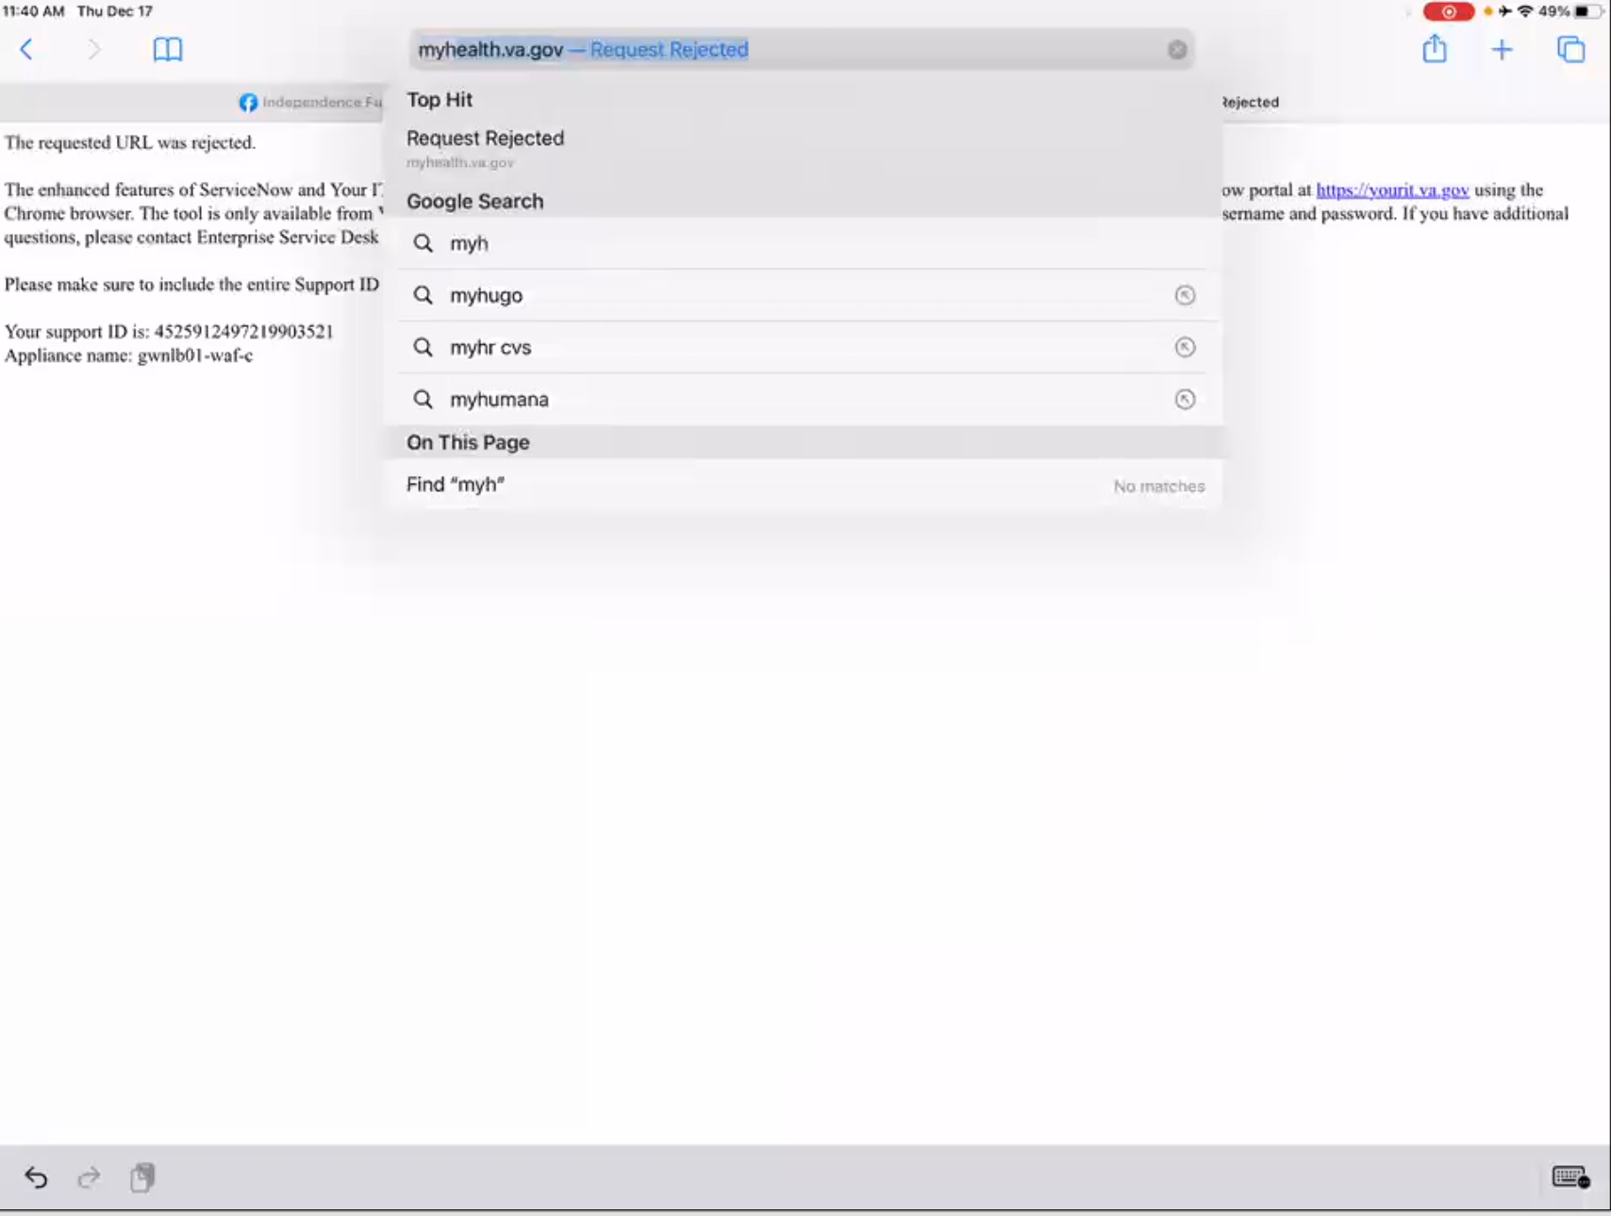

*Participant shares screen and starts typing in “myh” in URL bar of Safari.*

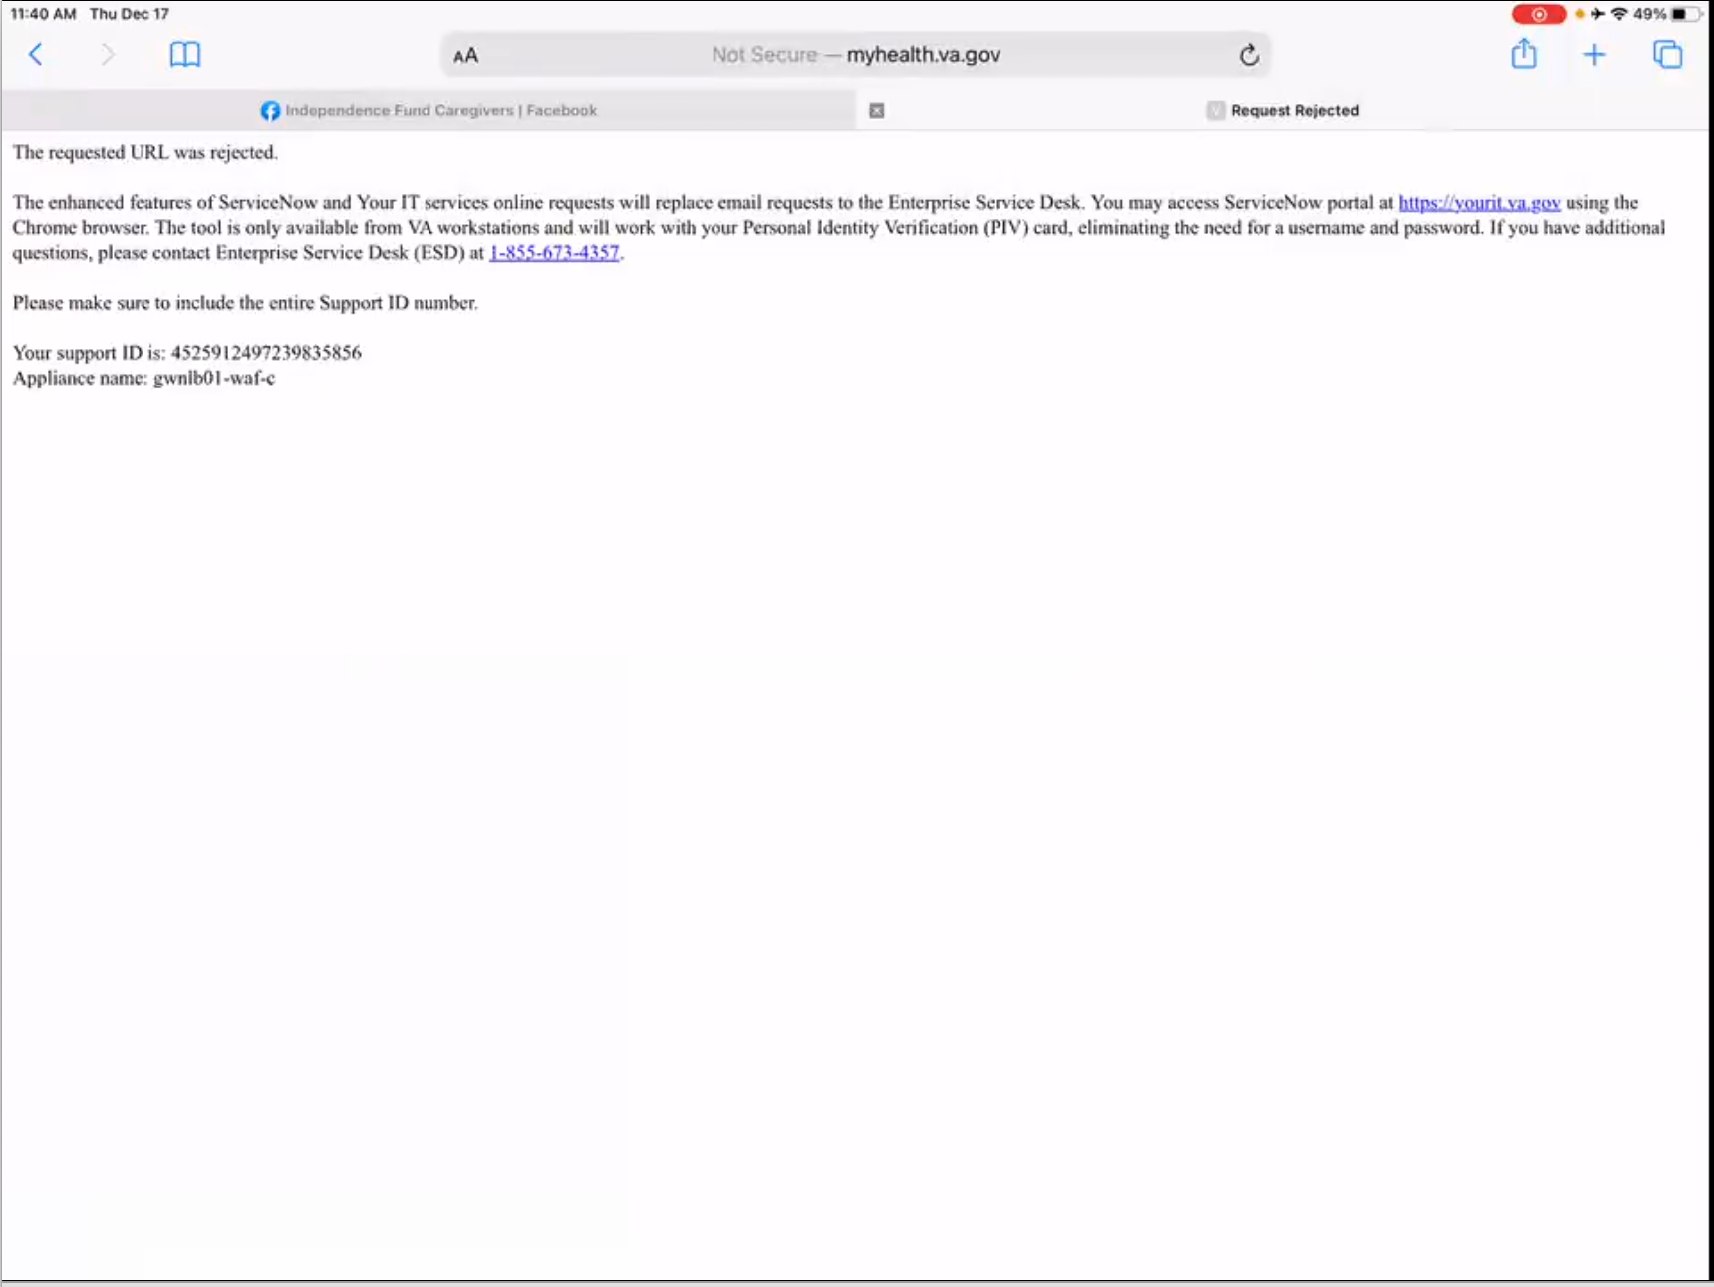

*Participant gets “Request Rejected” page.*

See that.

**Have you seen that before:**

No Ma’am.

**Well that’s not very helpful:**

No.

**How did you get here? Did you have it saved:**

I saved it.

*Moderator has Participant try to refresh page. Still gets same error. Participant refreshes page again and gets site to load.*

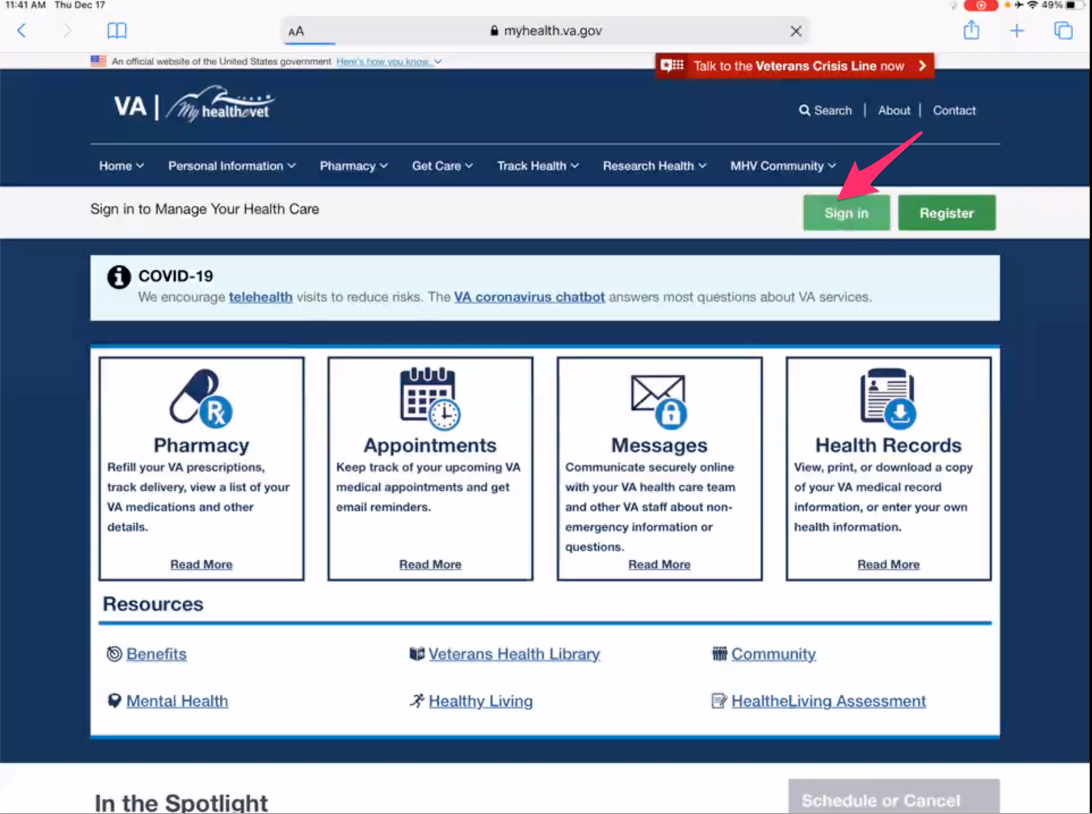

*Immediately upon site load Participant taps on green “Sign in” button in upper right of My HealtheVet home page.*

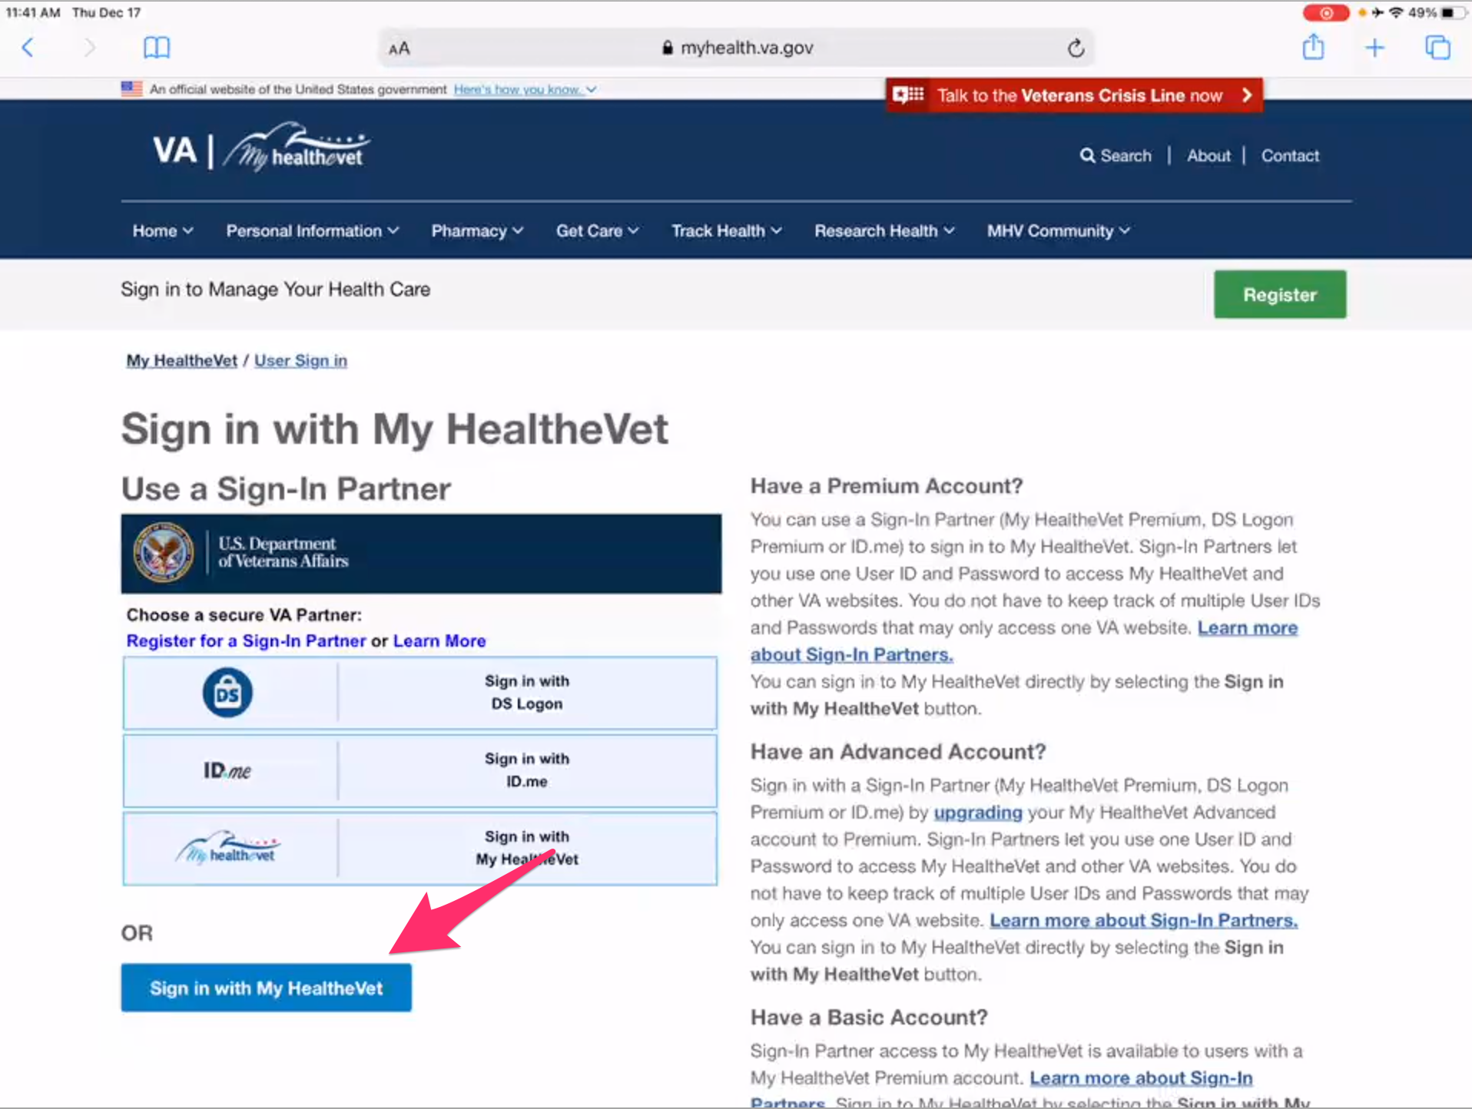

*Participant immediately taps blue “Sign in with My HealtheVet” button.*

**How did you know which the login option to choose:**

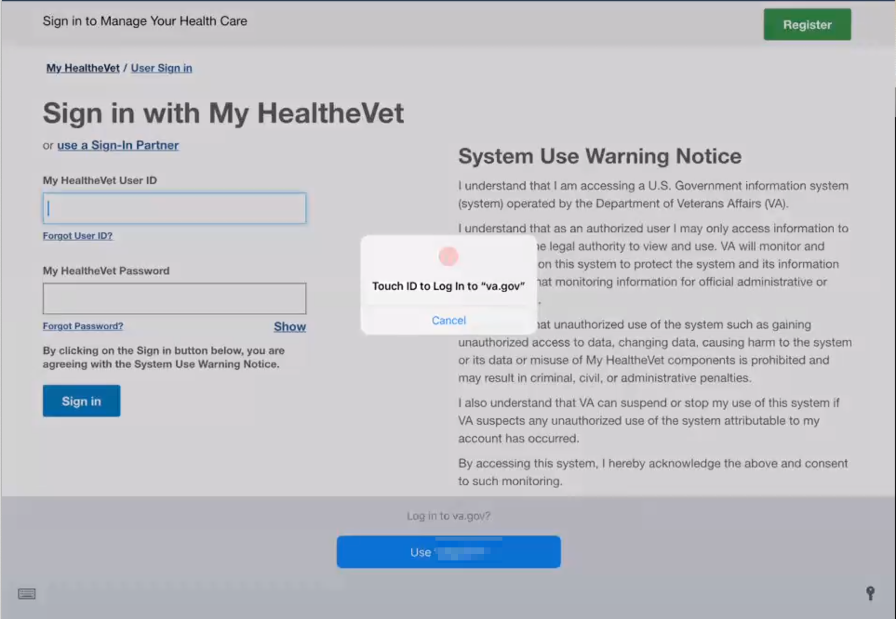

*Participant logs into My HealtheVet using Touch ID saved on iPad.*

Because I looked down and it said “sign in to My HealtheVet”.

And now I could do that. *Participant is referring to signing in via thumbprint.*

**How would you send a message:**

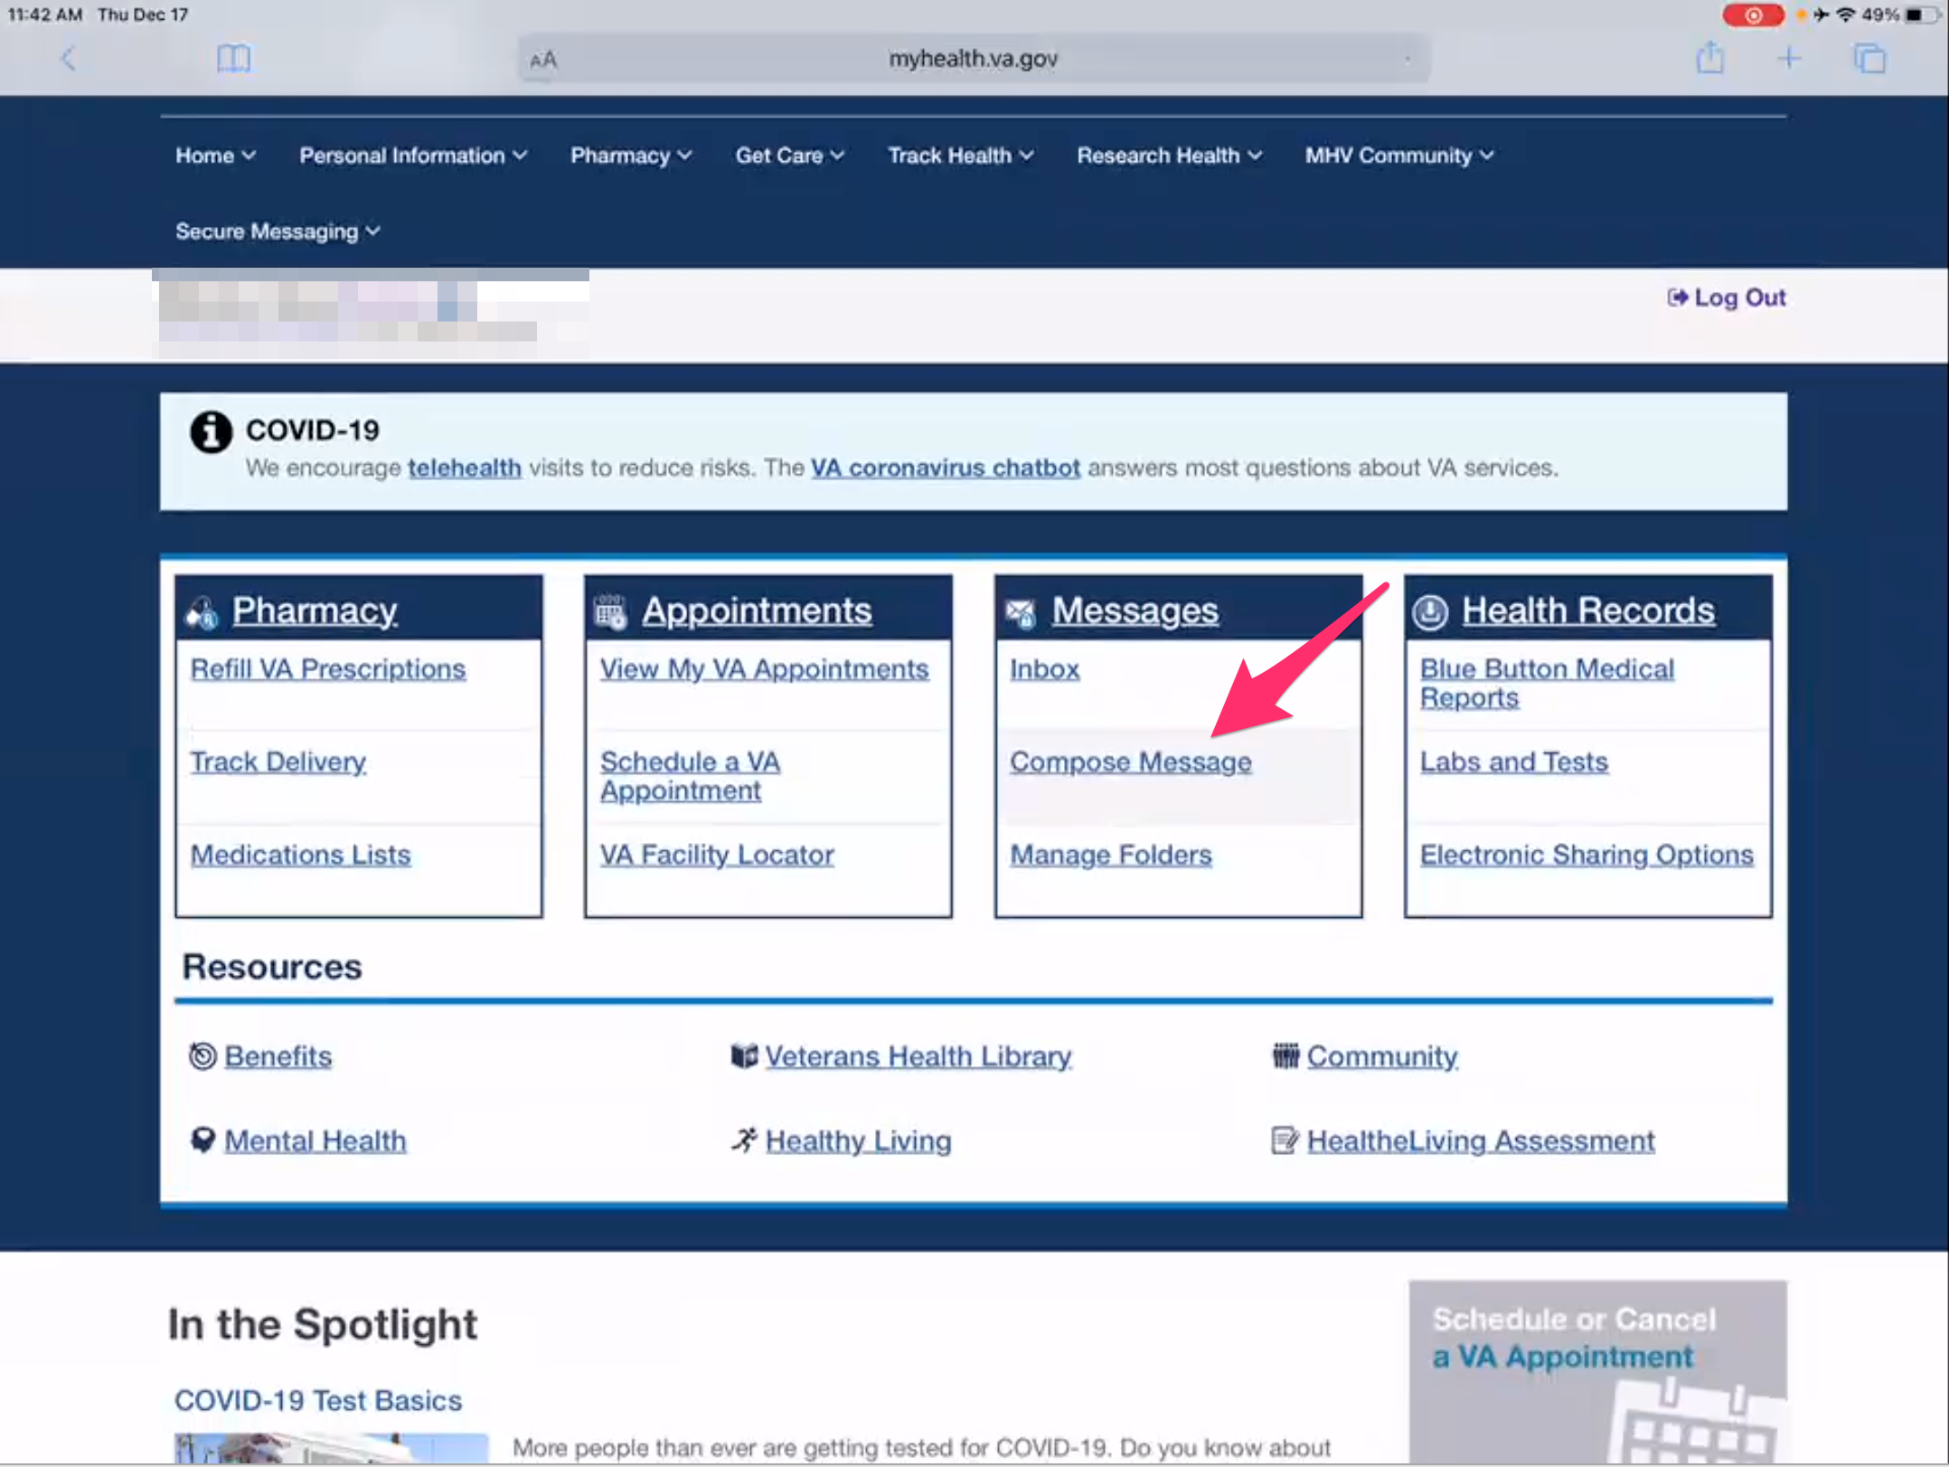

*Participant taps on “Compose Message” under “Messages” box on My HealtheVet home page.*

I go to message, compose a message. Scroll down.

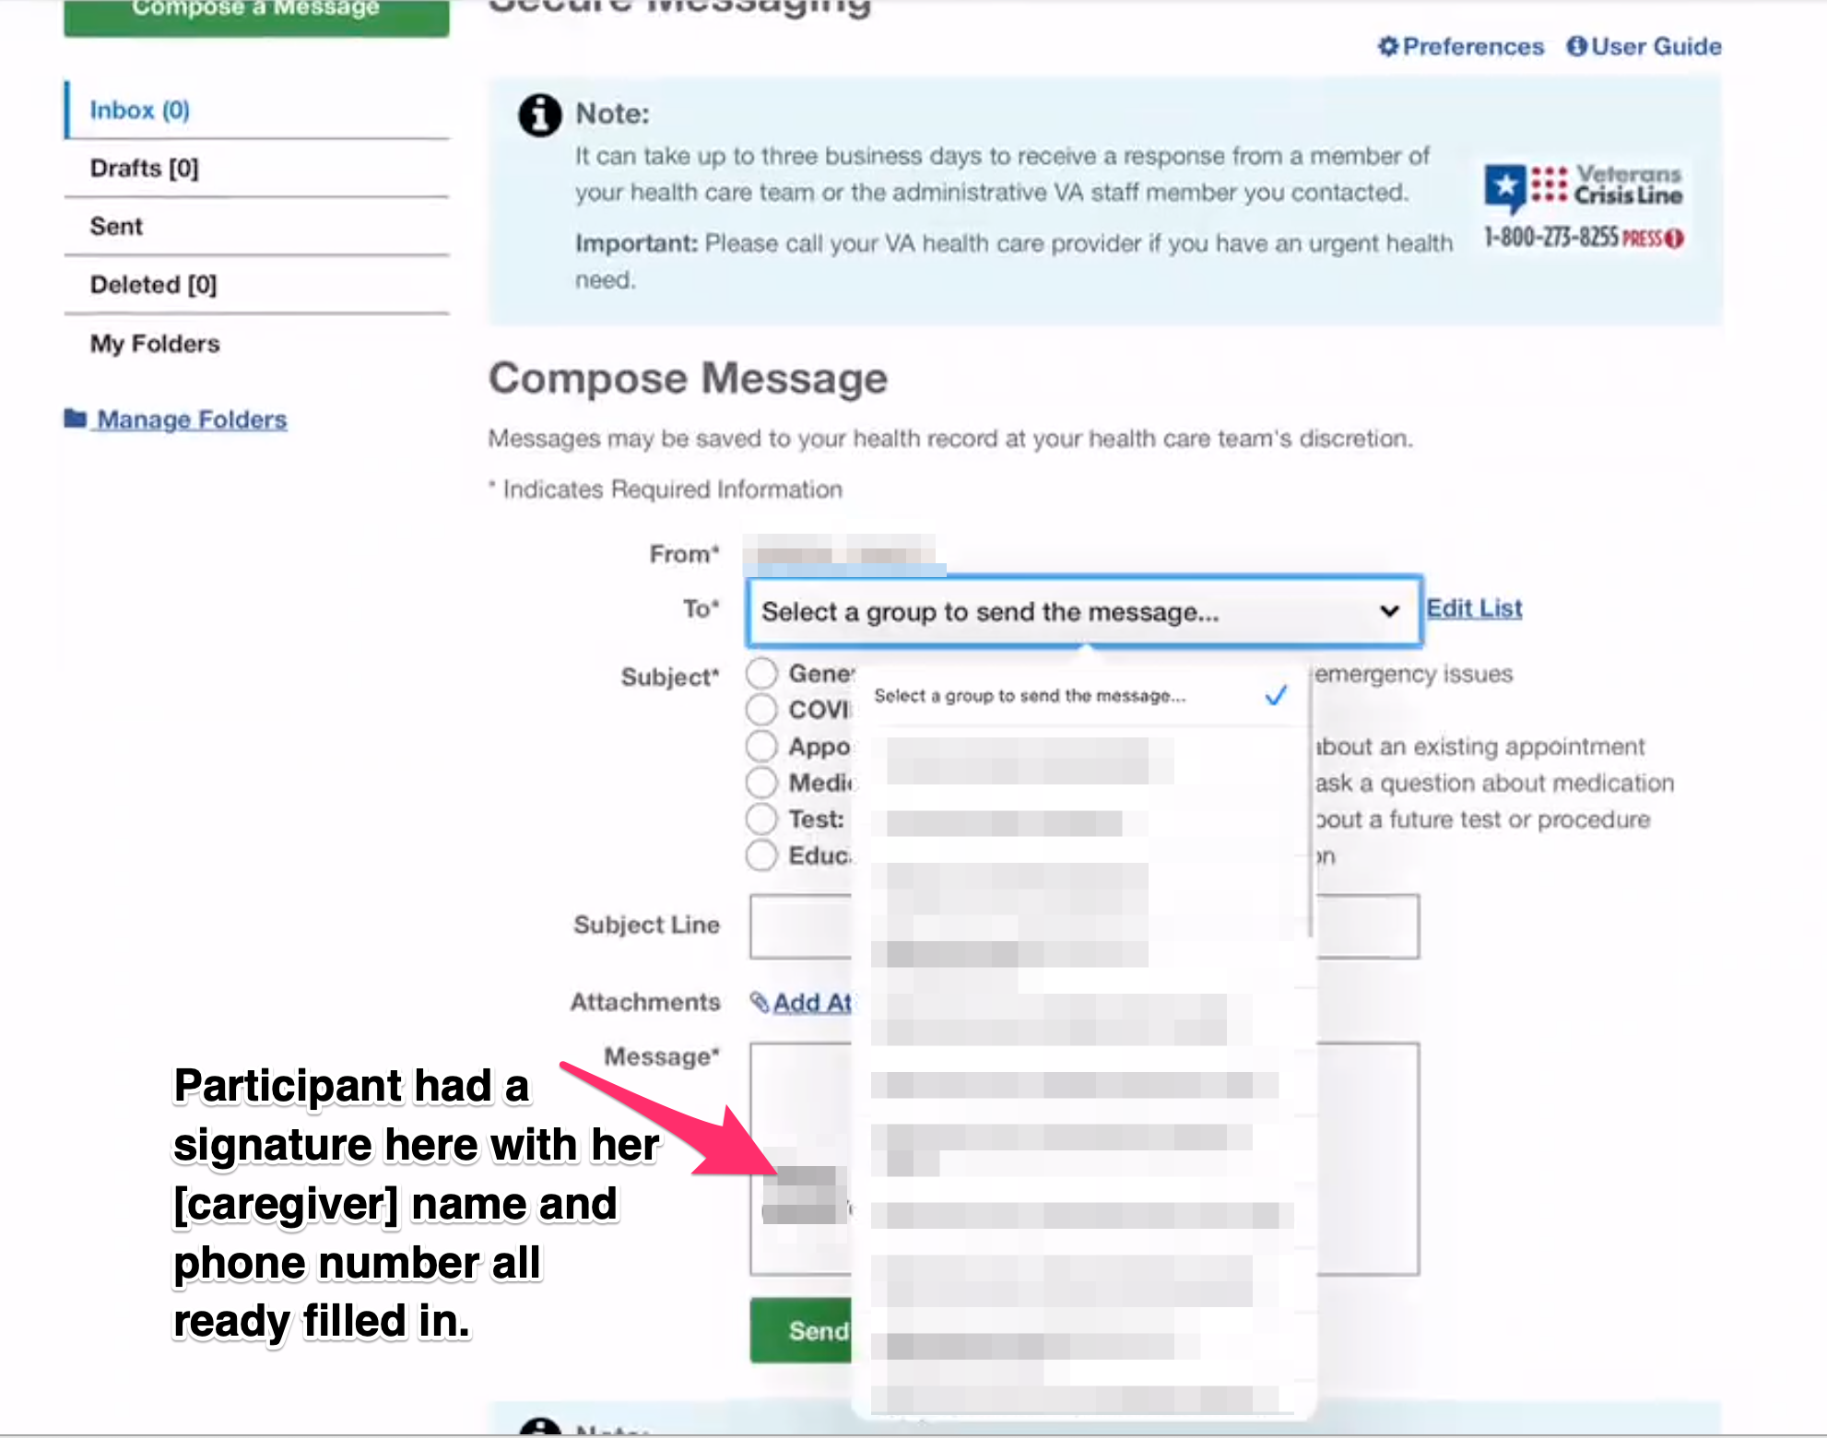

*Participant shows how to use “To” drop down form field to select the message recipient. Participant had her name and phone number pre-filled in the “Message” textbox for field which suggest she is using the signature feature of Secure Messaging.*

And then you go down and you can say your team or whatever.

Then I could say General. *Participant taps “General” radio button from “Subject” form field.*

And in the subject line I am going to write. *Participant taps on “Subject Line” text form field.*

And then here I write whatever. *Participant taps on “Message” textbox form field.*

**This is what you use to request equipment or the shoulder pillow you mentioned:**

Yes, I did it one time before. Others times I would call or something like that.

* **How would you refill a prescription [Veteran] have with the VA?**

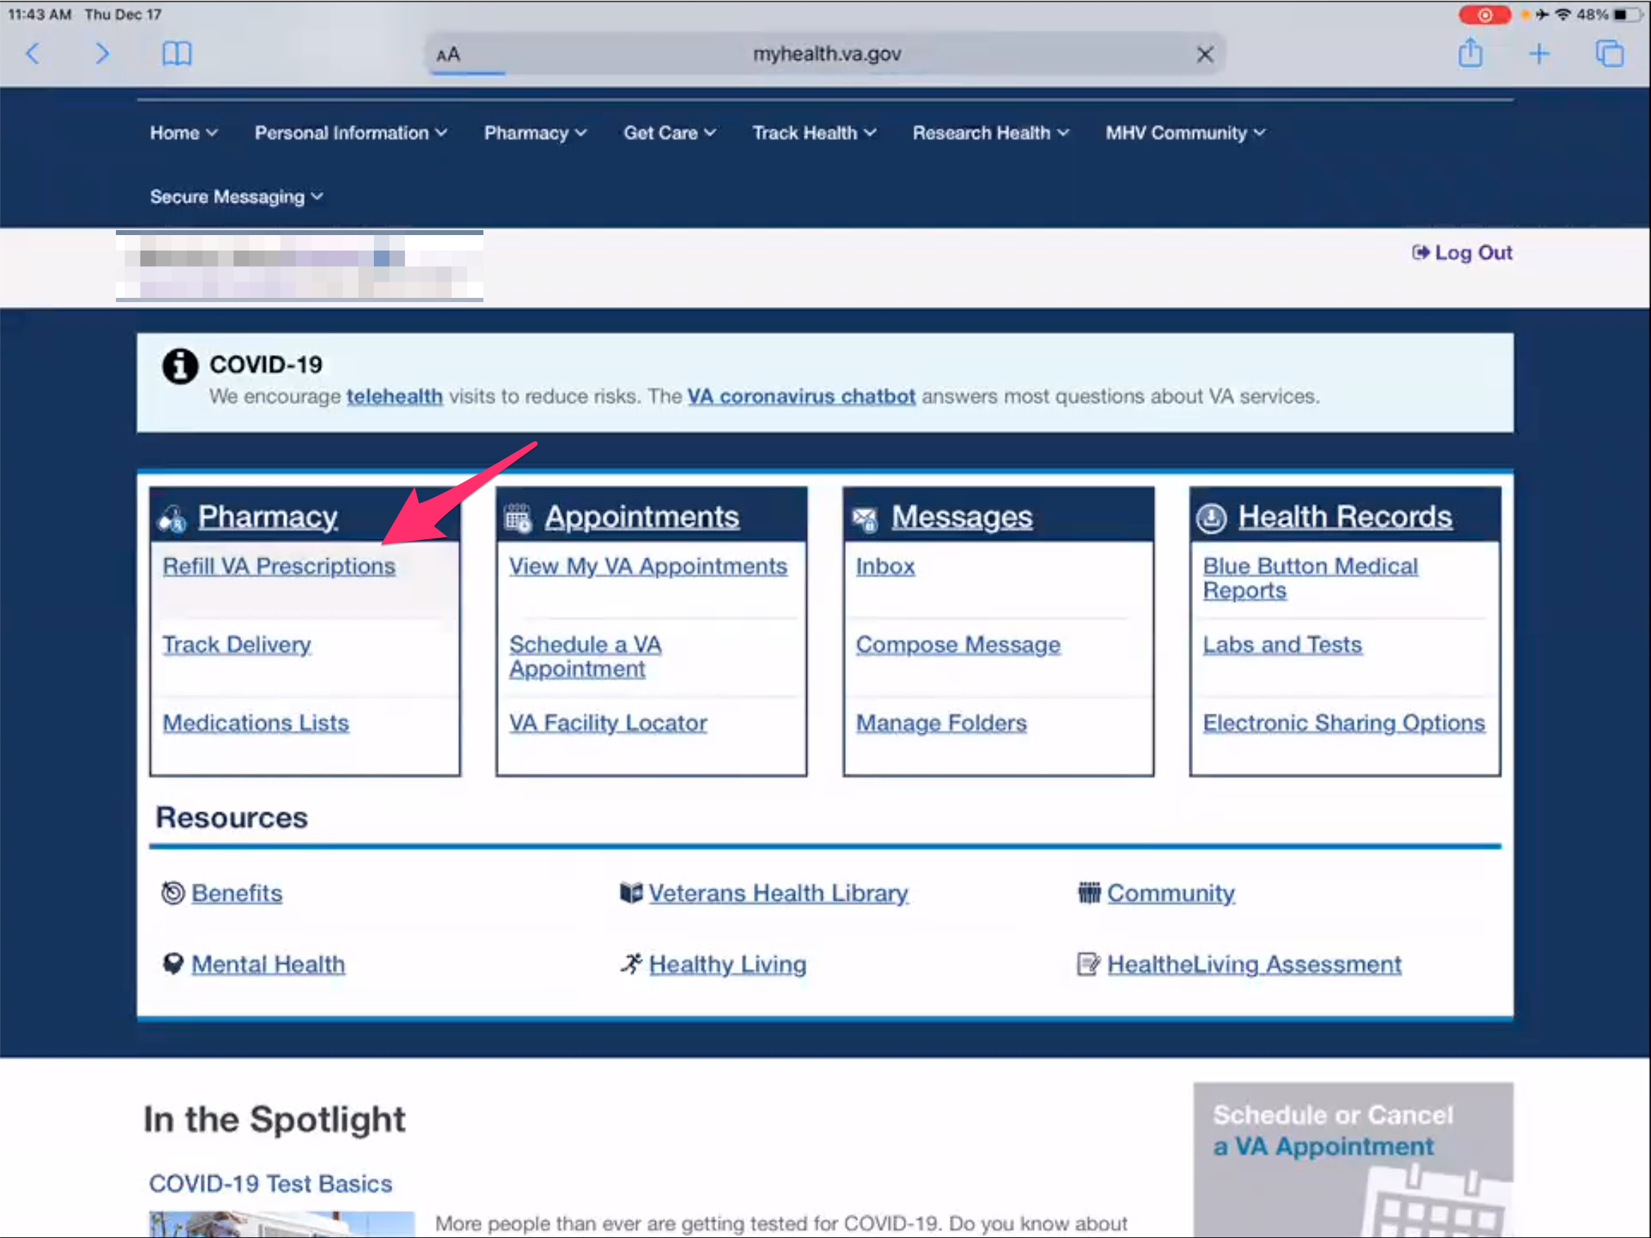

*Participant taps on back button in Safari to go back to My HealtheVet home page.*

*Participant taps on “Refill VA Prescriptions” link under “Pharmacy” box.*

I would go to pharmacy, refill.

**Is this how you normally refill prescriptions:**

That’s the way I do it.

**How do you like it:**

I love it, I have been using this for a long time.

It’s easy.

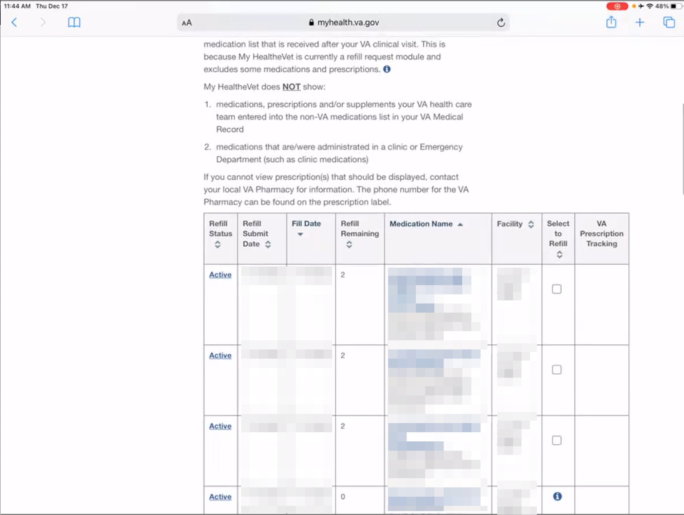

*Participant scrolls up and down Refill VA Prescriptions page showing prescription list table.*

And you can see when it is coming, how many more refills

Or if you don’t have any more refills, like here I will say, I am down to two, so I am going to call them and tell them.

* **How about an appointment for a yearly check up with [Veteran's] VA care team?**

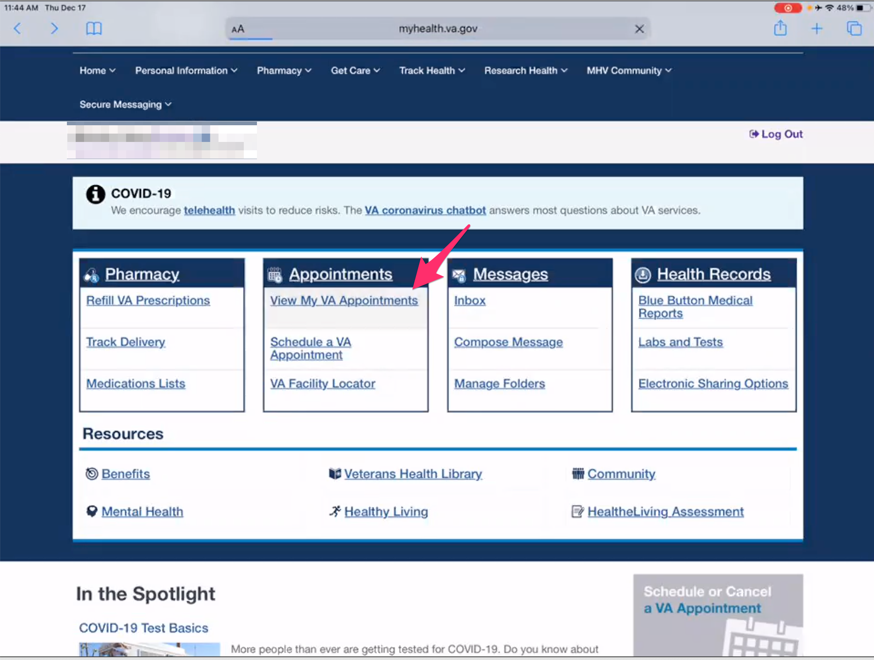

*Participant taps back button in Safari to go to My HealtheVet home page.*

*Participant taps “View MY Va Appointments” link under the “Appointments” box.*

Right here at appointments. Just like that.

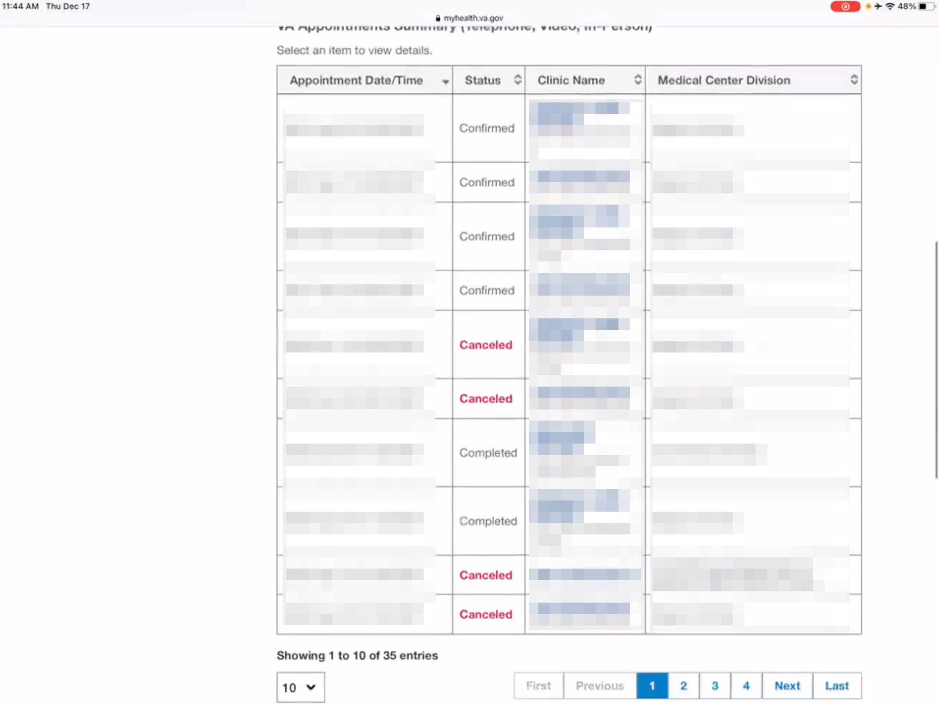

*Participant scrolls down View My VA Appointments page to show table list of appointments.*

**How have you liked using that feature:**

I like it.

I just wish it would like link, if you have appointments I wish it would link into your calendar from here. I just take the extra step to copy and past put it in my calendar.

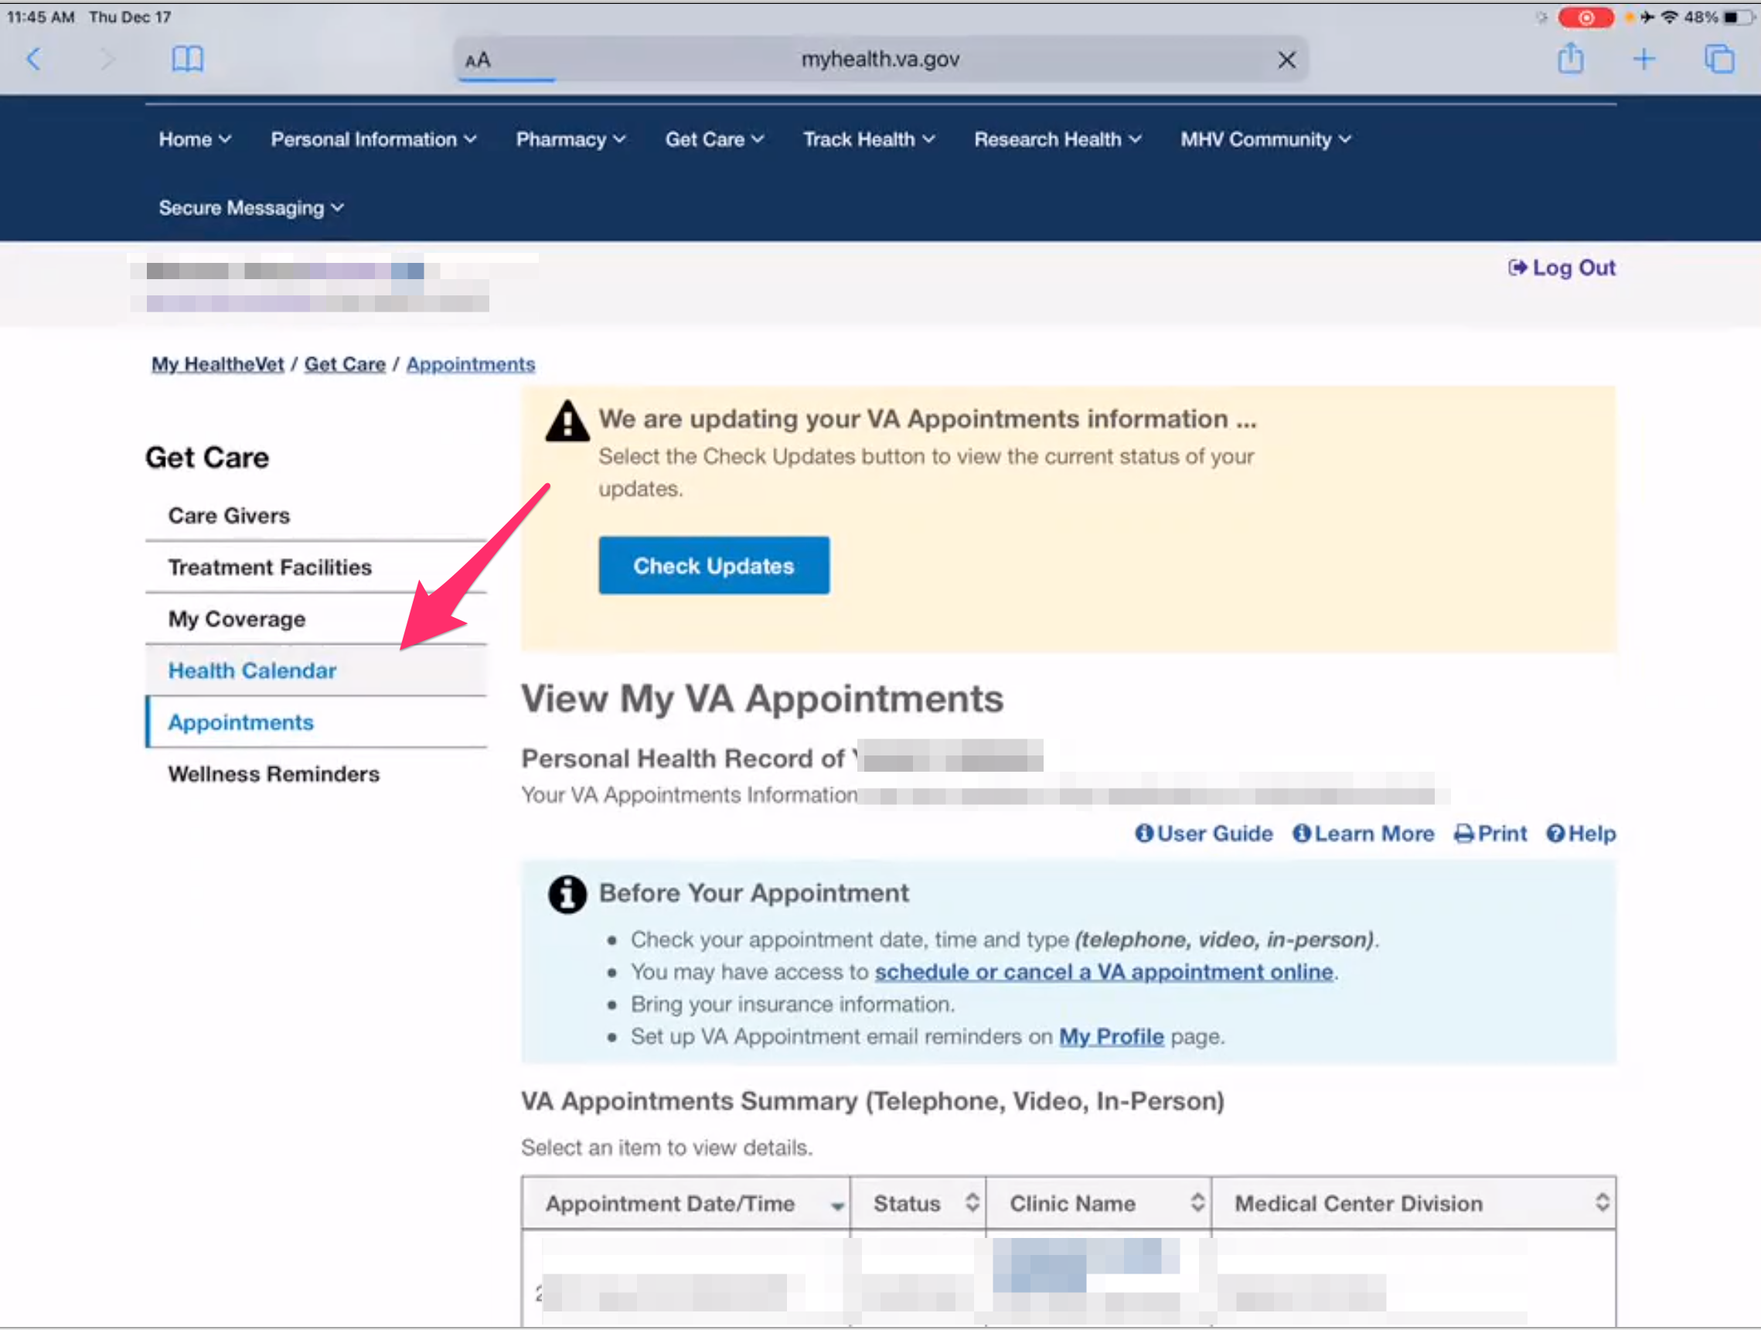

*Participant taps on “Health Calendar” in left sidebar menu.*

**Telehealth appointments show here as well:**

Yes, they do.

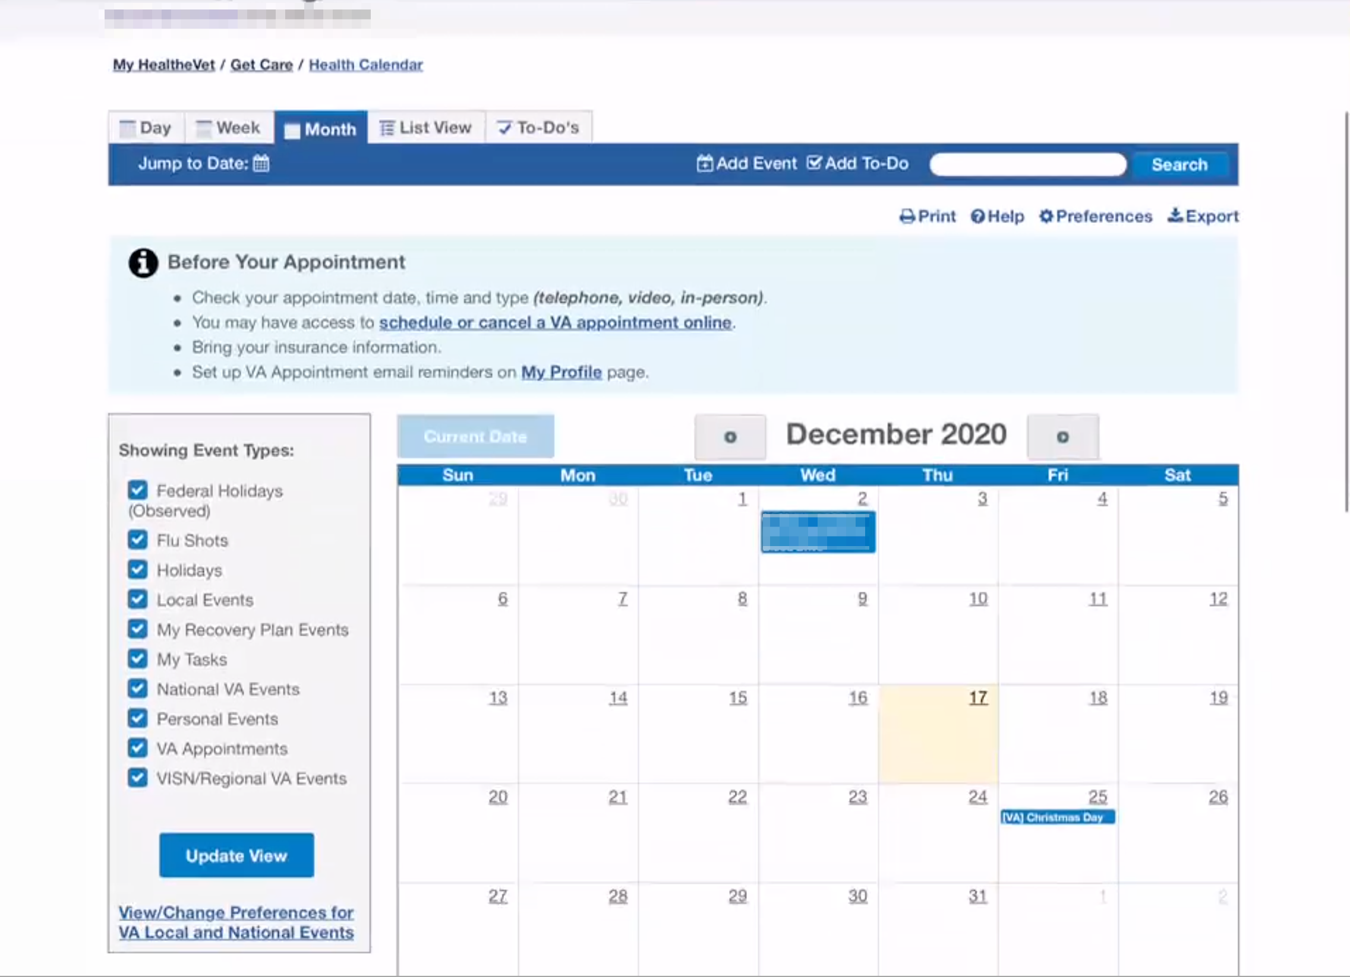

*Participant shows Health Calendar page.*

**Have you every scheduled a new appointment through here:**

No.

**How do you typically schedule:**

They call me and say hey he has an appointment.

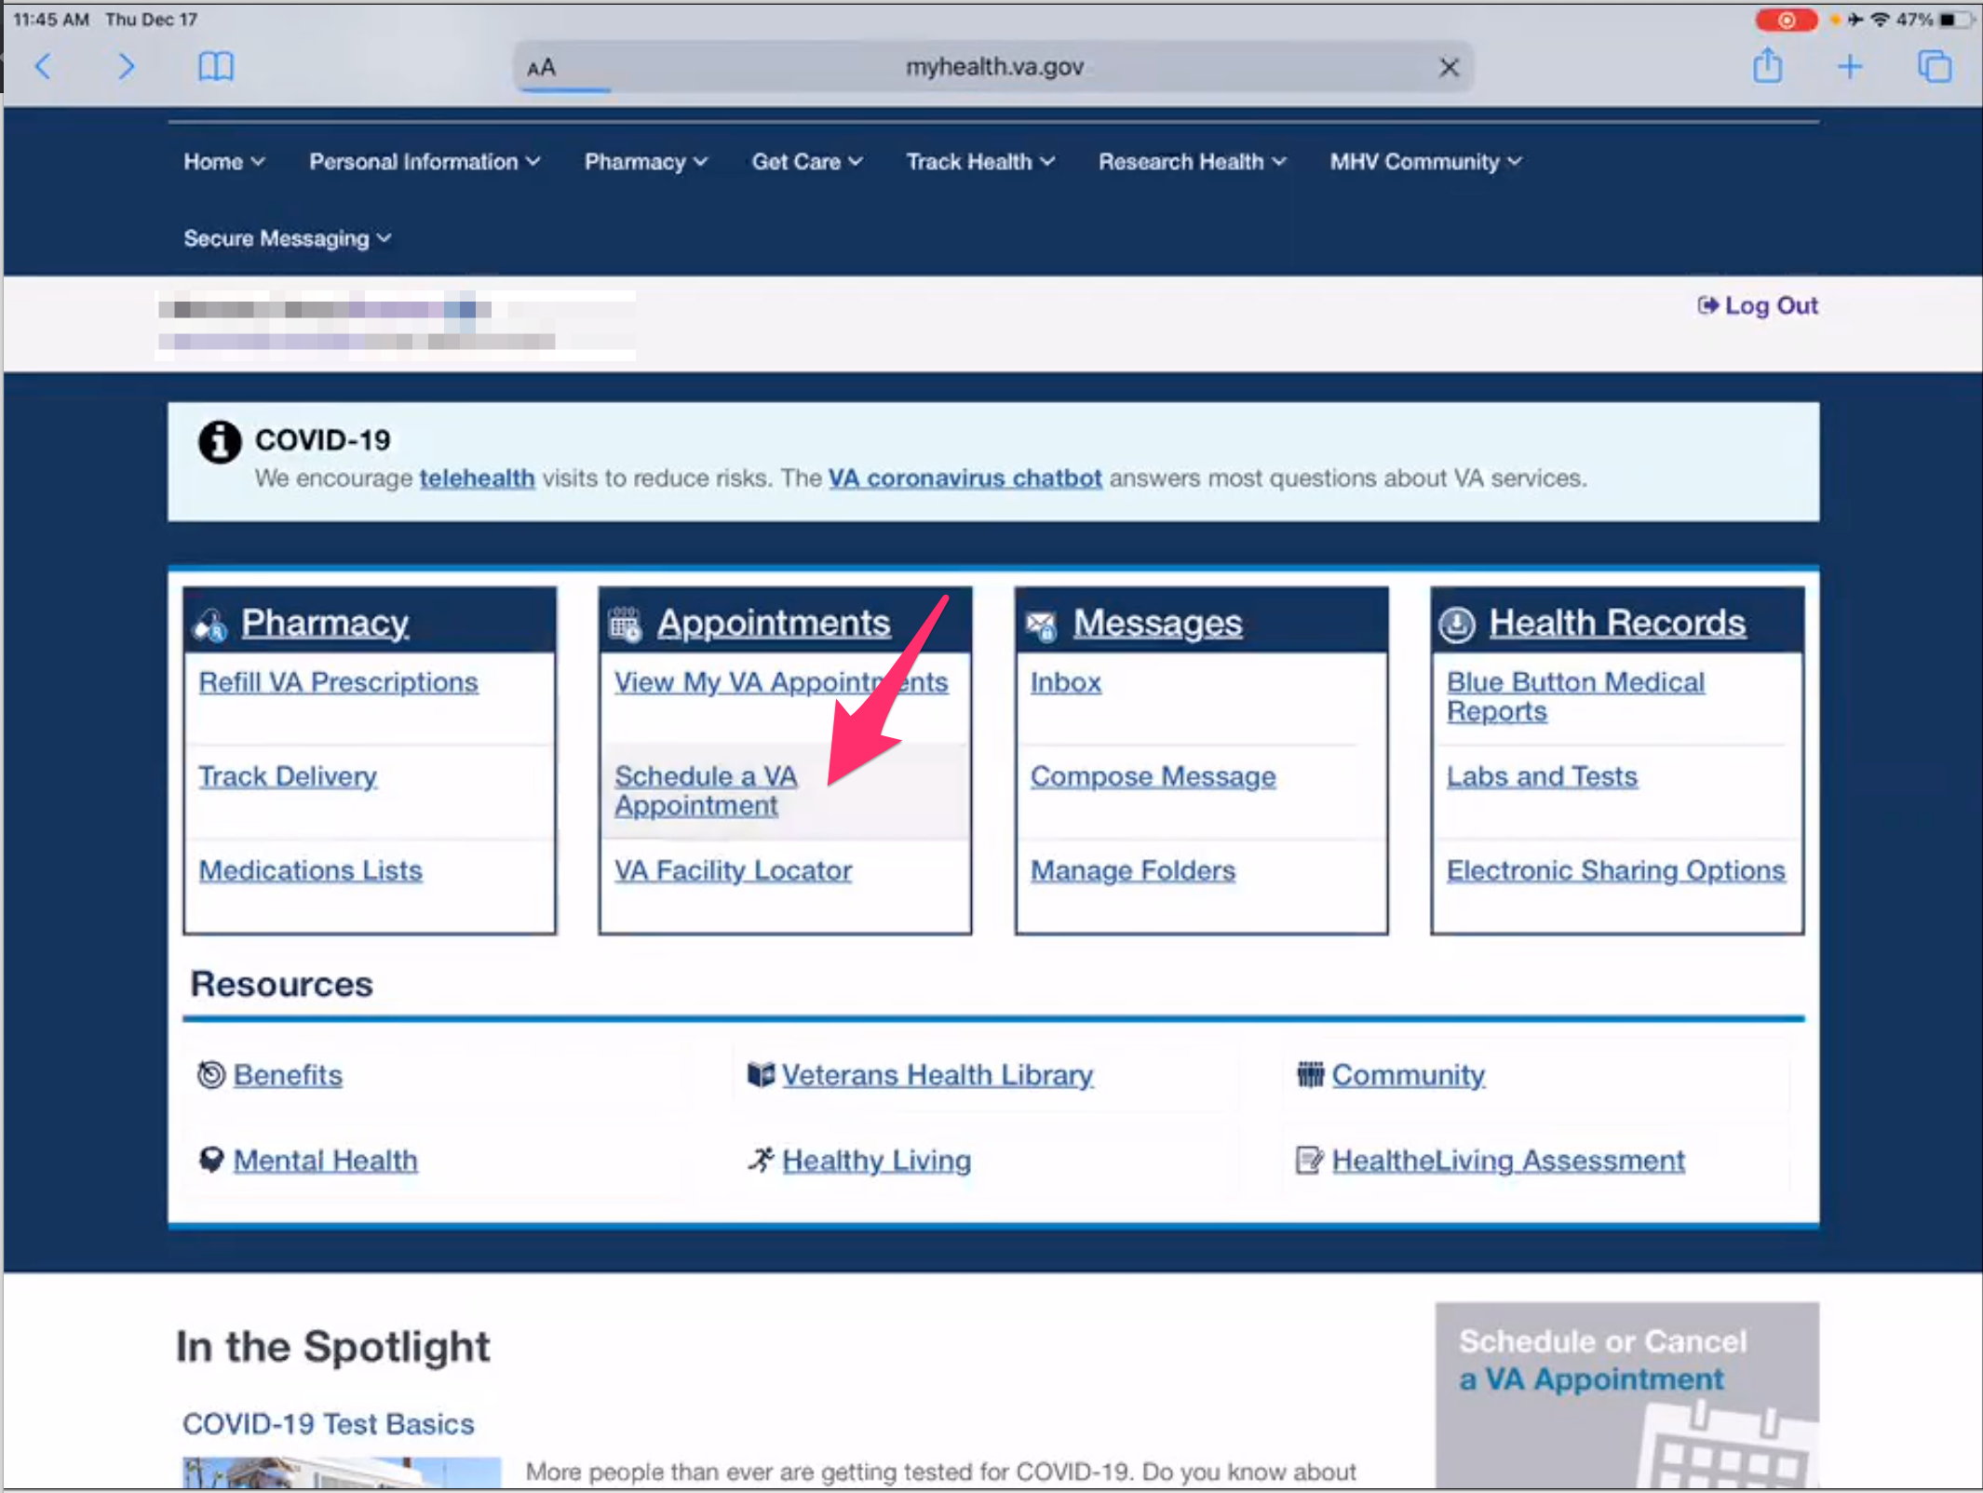

*Participant taps back button in Safari to go to My HealtheVet home page.*

*Participant taps “Schedule a Va Appointment” link under the “Appointments” box.*

But I see here now that you can schedule a VA appointment.

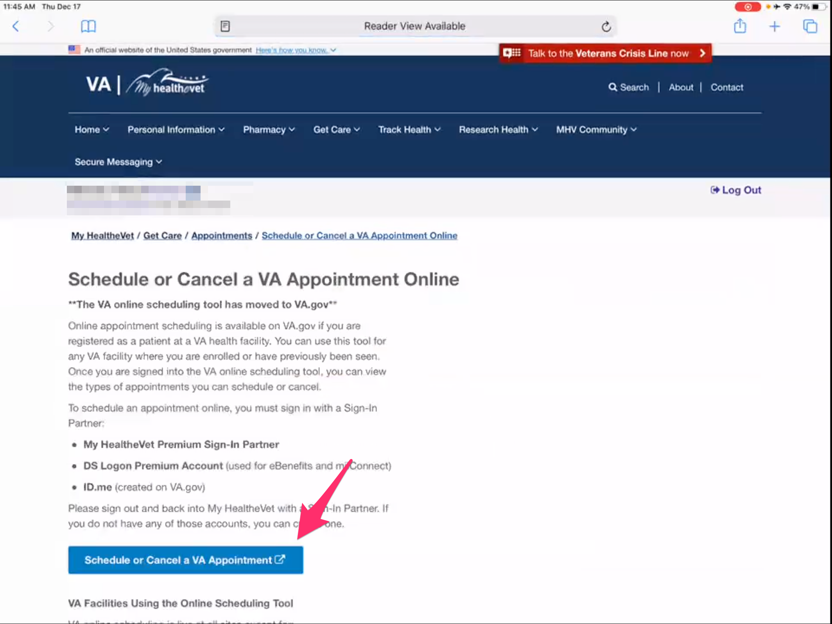

*Participant taps on blue “Schedule or Cancel a VA Appointment” button.*

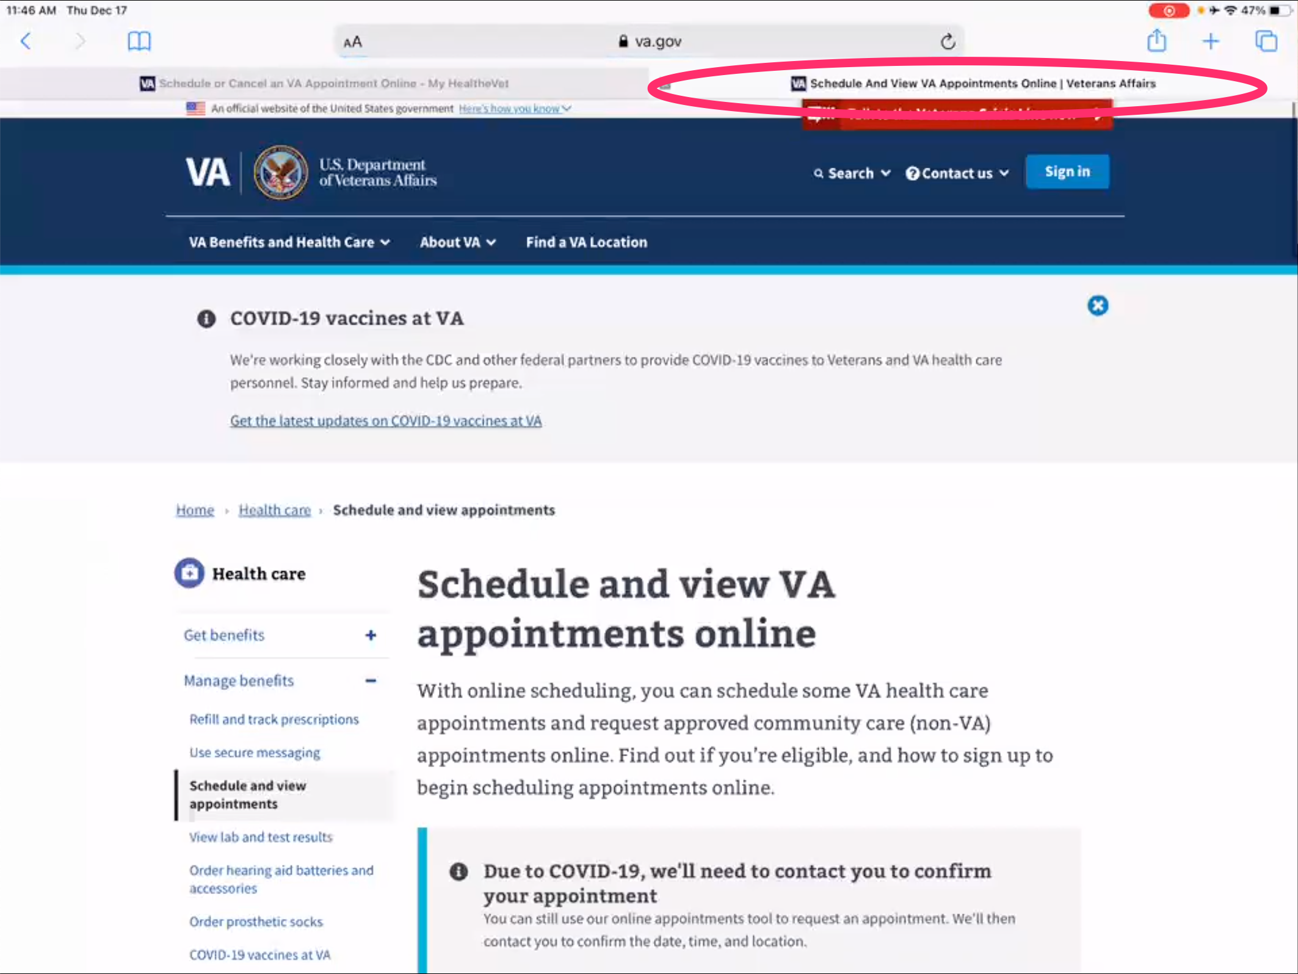

*A new tab opens in Safari and Schedule and View VA Appointments Online page loads on [VA.gov](http://VA.gov). Participant doesn’t comment about new tab or different website.*

Cool.

**What does it look like this is telling you:**

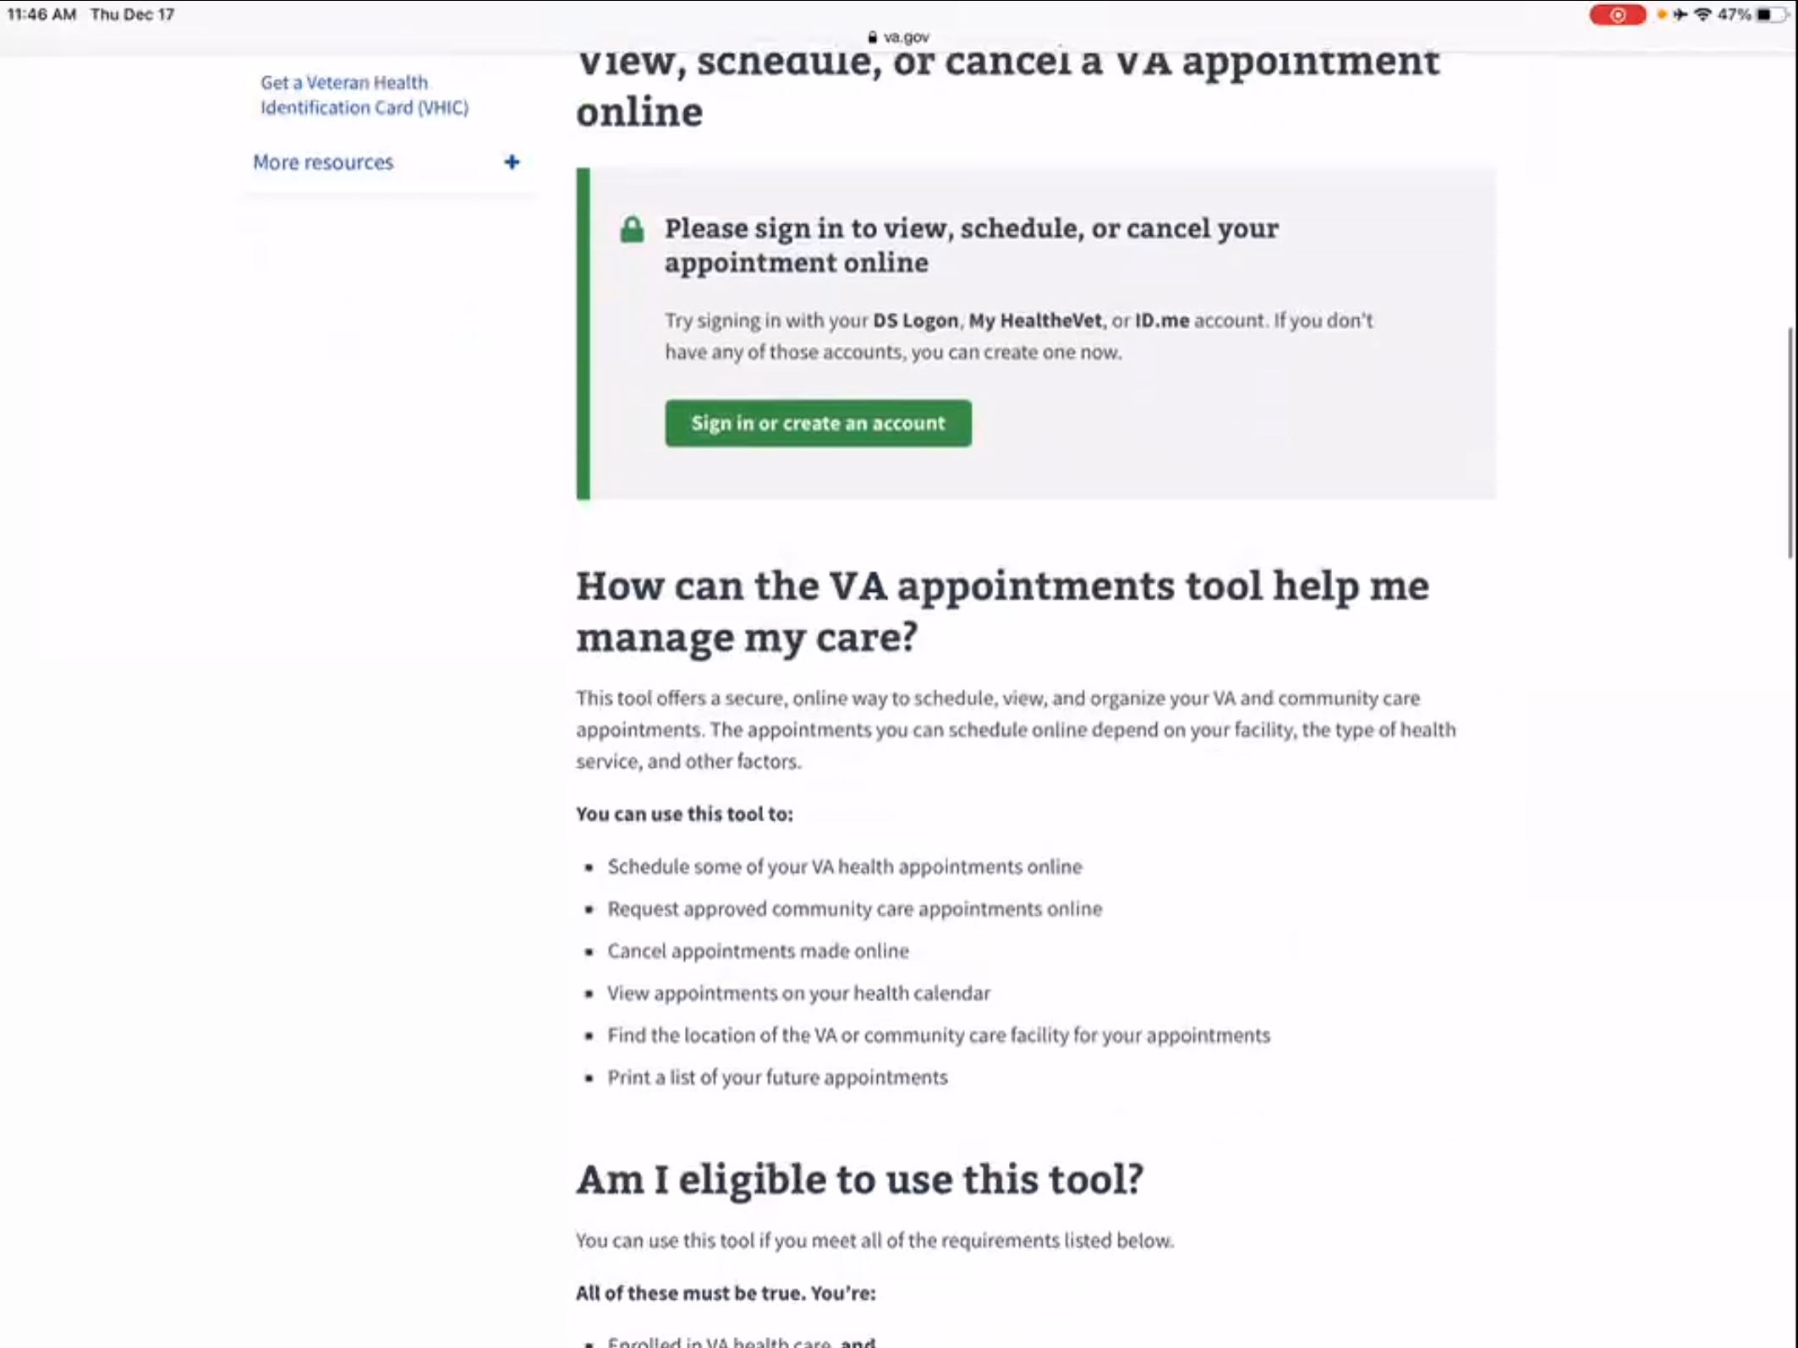

*Participant scrolls down page.*

You can view, cancel, or schedule and appointment online.

How can the VA appointments tool manage my care. *Participant is reading text on page. Participant scrolls through page.*

There is a lot of information in here which is cool.

**Is this something you think you could use:**

I could. Now that I know it is there.

*Participant closes Safari tab on [VA.gov](http://VA.gov) Schedule and View VA Appointments Online page and is now back on My HealtheVet home page tab.*

I didn’t pay attention to it prior.

**Providers normally call you to schedule and appointment:**

Yes.

**Is that for just primary care:**

For primary care and for psych. And the GI that is outside of there. His outside appointments don’t show up in here even though that the VA has authorized it. But they don’t show up in here.

**What does authorized it mean:**

They have authorized him to be seen by an outside provider

**What’s that process like to manage those outside appointments:**

They call me and I put it in the schedule. Andy they always email me so I can copy and paste it in the schedule

**I noticed you had the calendar on this website. Is that the schedule you are referencing or do you use another schedule:**

No. For outside things?

**Yeah or just his appointments in general:**

From here I can look at View my VA appointments but I transfer them into the iCal on the iPad, things like that.

I set reminders like 2 days before and then another one an hour before so we are ready.

* **This may not apply to your situation but how would you pay a VA health care bill, such as a copay?**

I don’t know. I have never been asked to pay one.

* **How would you update information on dependents on [Veteran's] VA benefits?**

I would just call in I guess. Call in the main number.

* **When it comes to your My HealtheVet account is this something your husband uses as well or is this just for you:**

No, he doesn’t know. I manage everything.

* **Would it be useful for you to have a separate login that it would indicate you as a caregiver are doing things or is doing it though his account been working okay for you:**

It has been working okay for me.

And they know it is coming from me. For some reason.

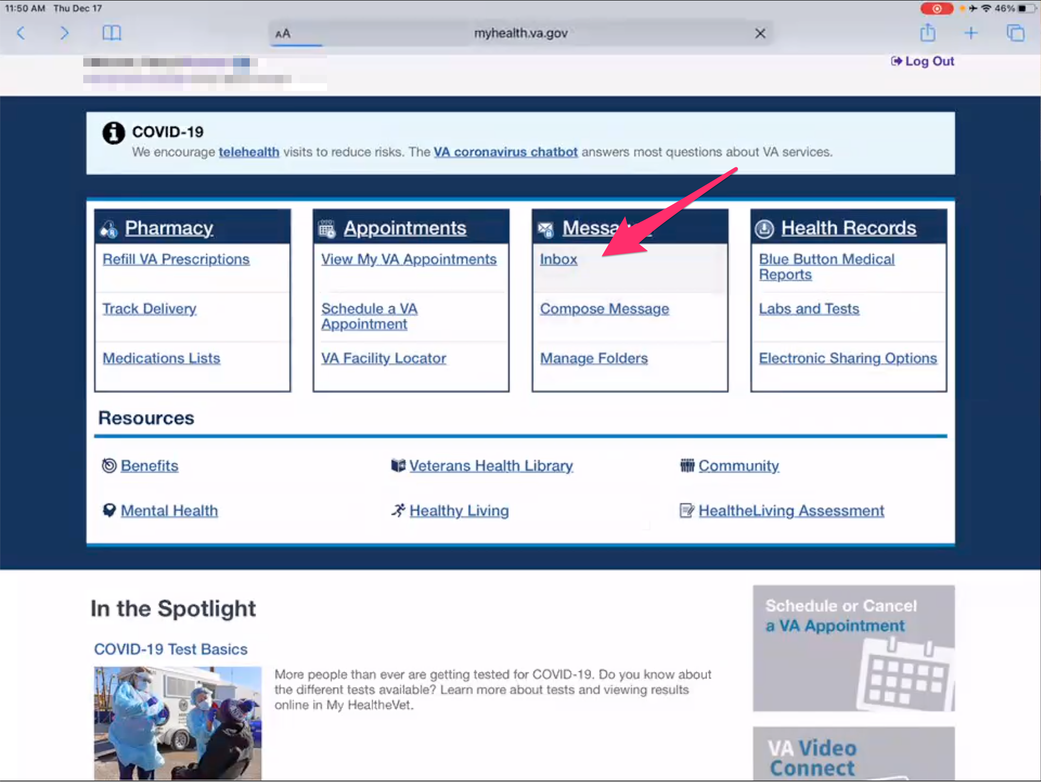

*Participant taps on “Inbox” link under “Messages” box on My HealtheVet home page.*

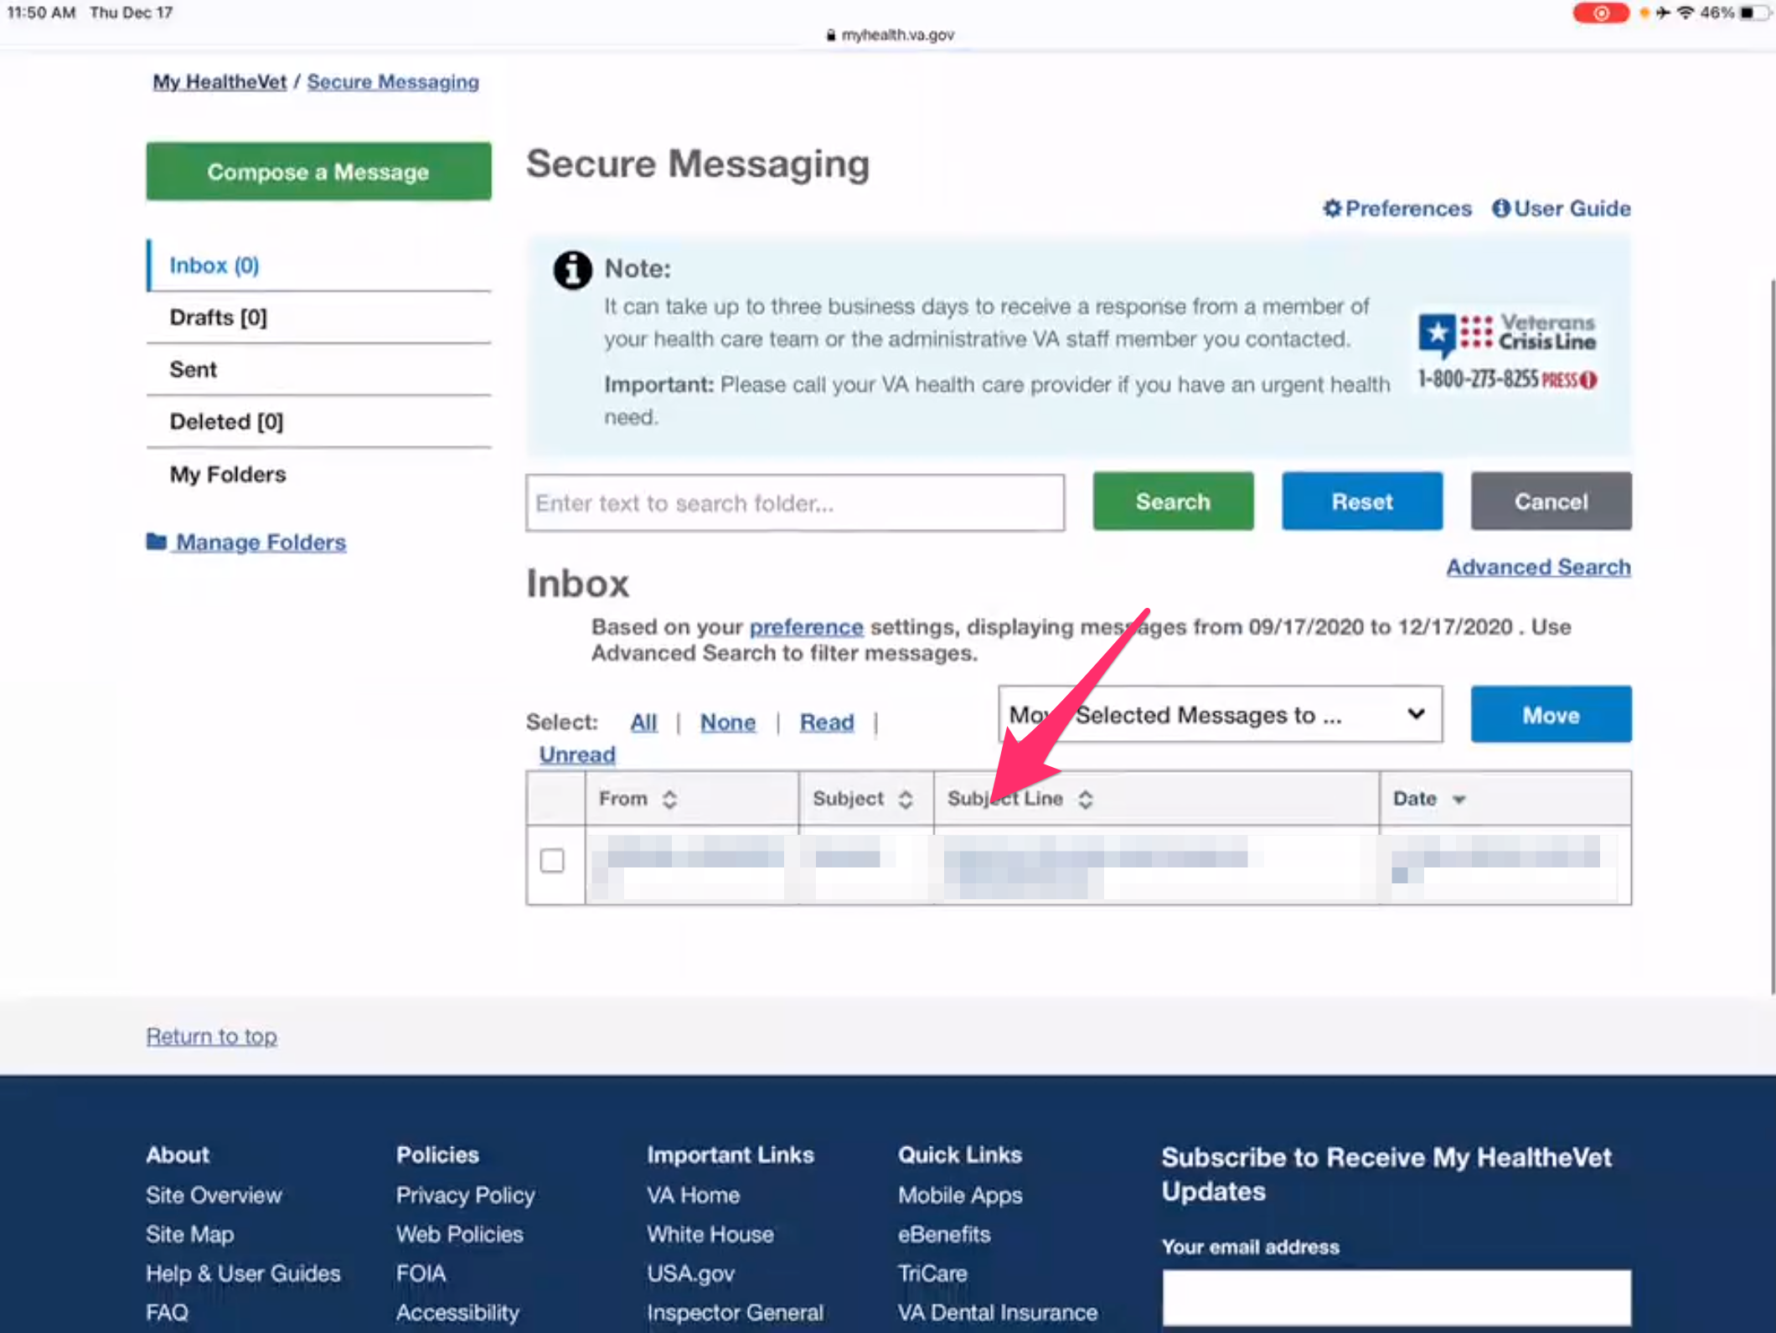

*Participant taps on link to open message in Inbox.*

I would assume they know. In Arizona they knew.

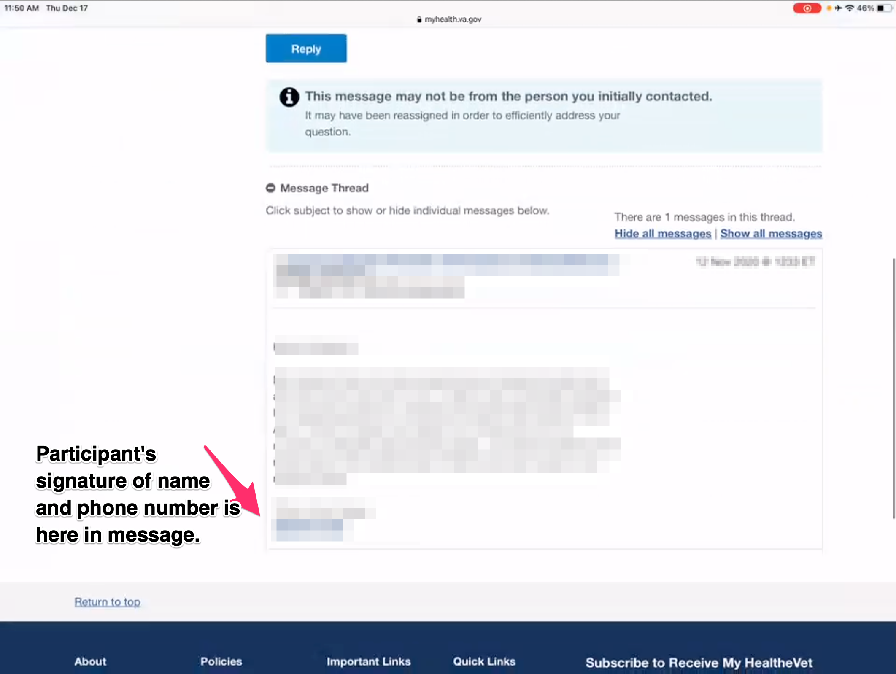

*Participant shows message in Inbox. Participant appears to name and phone number set as signature in message.*

My number is down there, he doesn’t have a number. *Participant seems to be referring to signature feature and has it set up in Secure Messaging.*

My phone number is down there.

**When you received response back from the message that you sent in this website:**

Yes, I receive a response.

**How did you know you had a new message:**

It hits my email that I have a new message from here.

**Branding and trust (5 minutes)**

Now I’d like to ask for your thoughts on My HealtheVet. (Confirm that participant has used My HealtheVet previously. If not, amend questions below to capture their first impressions while looking at a logged in account.)

1. **How would you describe My HealtheVet to a fellow caregiver?**

Explore, don’t be scared to explore.

There are different options. Just take a couple days to explore and see what is on there.

Make sure to look at the pharmacy, make sure to look at the appointments.

Make sure that your primary care, your psych and all that is in the drop down for messages for you to message them.

**Anything you found as you have explored that is useful or didn’t know about:**

That I can schedule an appointment.

1. **How would you describe VA health care to a new caregiver:**

I would describe it as I am appreciative for having healthcare for my husband being able to use it.

Secondly, it is different and I can say experiences can be different at different hospitals/regions. Which I found out moving here. It is very different.

I miss Arizona. I miss that personal thing. They knew us and a lot of the things they had there they don’t have here. We didn’t just have to rely on the clinic, the hospital was close.

For me, I do all of the driving. 3 hours away is too far. That's too far. They say that they have a shuttle but we aren’t getting on a shuttle. There’s COVID plus my husband has the IBS issues. It would be embarrassing for us to be on there and him to have an accident.

I would tell them if you are moving or something like that really do the research. Do your homework as to how far away are you from care. Of having everything.

1. **On a scale from 1-5, with 1 being very dissatisfied, and 5 being very satisfied, how satisfied are you with My HealtheVet?**

I would say 5 because I trust a lot of things until you give me a reason not to.

So I am giving it the benefit of the doubt. So far it has been working and everything I need is there. I just wish that the hospital is as close to me as My HealtheVet is. *Participant laughs.*

1. **On a scale from 1-5, with 1 being very low, and 5 being very high, how would you rate your trust in My HealtheVet?**

5.

**What makes it a 5.**

So far it has not failed me. When I put up something, or I order the medication, or I am communicating with the doctors through it.

It has not failed me besides logging in today that was the first time I ever gotten that. But hey, it’s technology. It isn’t fool proof.

**My HealtheVet patient portal (15 minutes)**

Let's take a look at My HealtheVet together.

Moderator will ask participant to share screen if not already, or show logged in My HealtheVet account. **(5 minutes)**

1. **What do you use this website for the most?**

Medications. Refills.

1. **What do you find the most valuable on this website?**

*Participant thinks about this for many seconds.*

That you are able to communicate with the doctors in some form or fashion.

1. **What do you wish this website did that it doesn’t do right now?**

No, I mean I don’t know what else I would want it to do.

**Thank you and closing (2 minutes)**

**Feedback:**

No. Not that I can’t think of. I am sorry for being loquacious at times. Just things that are my mind to share. Thank you so much I appreciate it.